Exit Ticket
Look at the following figure
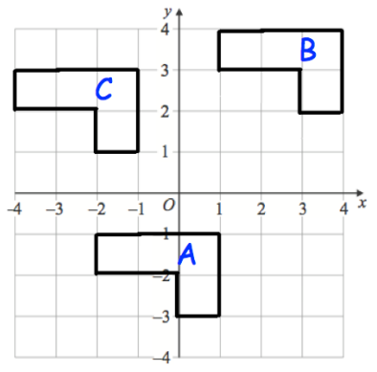
a) Write down the translation vector that would take A to B.

b) Write down the translation vector that would take B to C.

c) Write down the translation vector that would take C to A.

