- The diagram shows shape A on a coordinate grid.
draw the image of shape A after each translation
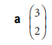
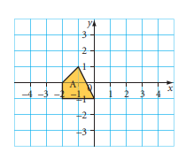

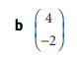

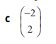

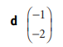

- The diagram shows triangle B on a coordinate grid.
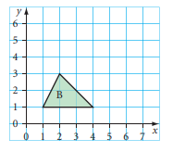
Draw the image of triangle B after reflection in the line:

(You Can use the following grid for each options )

- This is part of Oditi’s homework
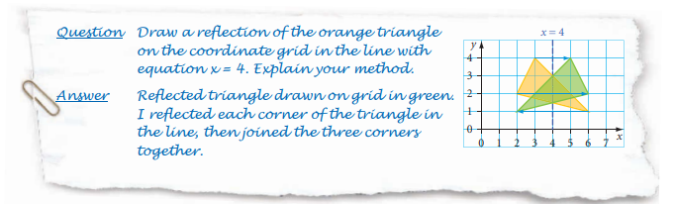

Use Oditi’s method to draw these reflections.
