**Objective:** To create scratch program while utilizing logical thinking to create efficient and organized Scratch programs with static objects.

**Main Task:**

1. Put the steps in the algorithm below in the correct order. The algorithm is for a conversation between two characters. The **Prince** should speak first, then change costume. The **Horse** should then reply. /6

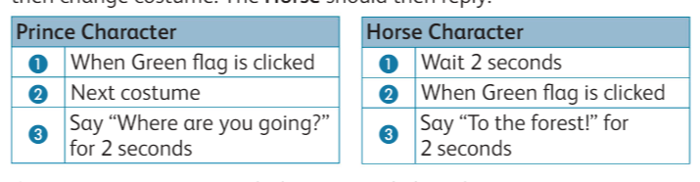

|  |  |  |  |
| --- | --- | --- | --- |
| **Prince Character** | | **Horse Character** | |
|  |  |  |  |
|  |  |  |  |
|  |  |  |  |

1. Create a program to match the corrected algorithms above. /4
2. Add two Backdrops to your project: **Castle 1** and **Woods.** /2
3. Click on the Backdrop thumbnail and add code so that: /2

When the **Green flag** is clicked, the backdrop switches to the **Castle 1** Backdrop.

After five seconds, the backdrop switches to the **Woods** Backdrop.

1. Add the **Tree 1** sprite as a static object. /2
2. Change the code created in part 2 so the **Horse** speaks for twice as long. /2
3. Add the following code to the **Horse** sprite. Run your final program and save it. /2

**Extension Task:**

Once you have finished, you can extend the story. You could:

1. add extra lines of conversation.
2. get the Horse and Prince to move.
3. change the backdrops and continue the story.

|  |  |  |  |
| --- | --- | --- | --- |
| **Rubric for Creating Program** | | | |
|  | 1 | 2 | 3 |
| Create Project |  |  |  |
| Add Sprites |  |  |  |
| Set Backdrops |  |  |  |
| Make codes for Sprites. |  |  |  |
| Include a static object |  |  |  |
| Run the program |  |  |  |
| **Key**:   1. Needs more opportunities to develop this skill. 2. Beginning to demonstrate this skill. 3. Has achieved this skill. | | | |