Objective: To create scratch program while utilizing logical thinking to create efficient and organized Scratch programs with static object.

- Algorithm
Prince Character |  | Horse Character
 | When Green flag is clicked |  | When Green flag is clicked
 | Say “Where are you going?” for 2 seconds |  | Wait 2 seconds
 | Next costume |  | Say “To the forest” for 2 seconds

- Program for algorithm above
Prince character Horse character
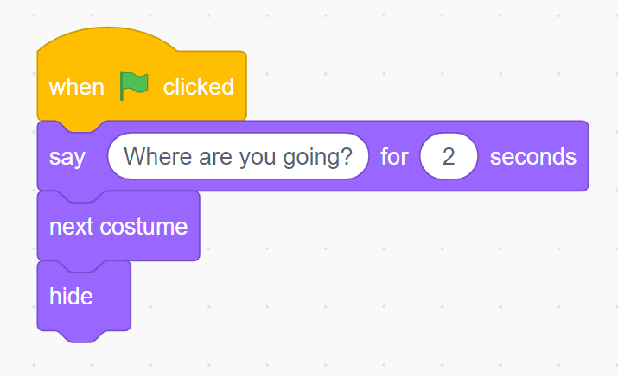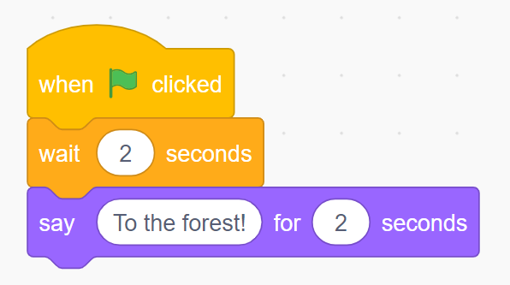
- Program for Backdrop
