**Chapter 3: Opportunities, risk , legal and ethical considerations**

**Revision worksheet**

**Test topics:**

Chapter 2: 2.4: Franchise and Social Enterprise

Chapter 3: Opportunities, risk, legal and ethical considerations.

**Revision questions:**

**Q1. Define the following key terms:**

|  |  |
| --- | --- |
| **Key terms** | **definition** |
| Franchise |  |
| franchisee |  |
| franchisor |  |
| reward |  |
| opportunity |  |
| risk |  |
| risk-keen |  |
| risk optimizers |  |
| risk reducers |  |
| risk averse |  |

**Q2. Name the various types of risks facing an enterprise and give a brief explanation of these:**

**……………………………………………………………………………………………………………………………………………………………….**

**……………………………………………………………………………………………………………………………………………………………….**

**……………………………………………………………………………………………………………………………………………………………….**

**……………………………………………………………………………………………………………………………………………………………….**

**……………………………………………………………………………………………………………………………………………………………….**

**……………………………………………………………………………………………………………………………………………………………….**

**……………………………………………………………………………………………………………………………………………………………….**

**……………………………………………………………………………………………………………………………………………………………….**

**……………………………………………………………………………………………………………………………………………………………….**

**……………………………………………………………………………………………………………………………………………………………….**

**……………………………………………………………………………………………………………………………………………………………….**

**Q3. The table below shows what a SWOT analysis includes:**

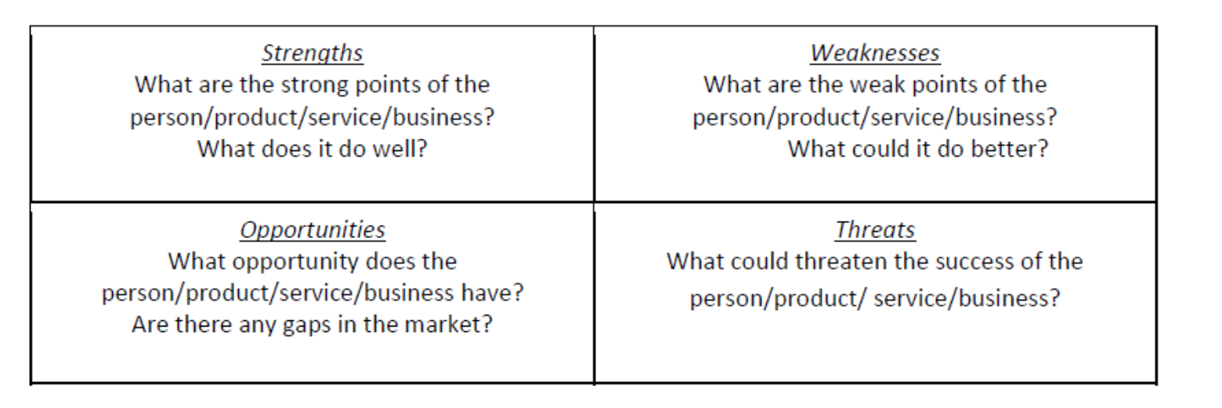

**Fill the following table in a similar way for the PEST analysis:**

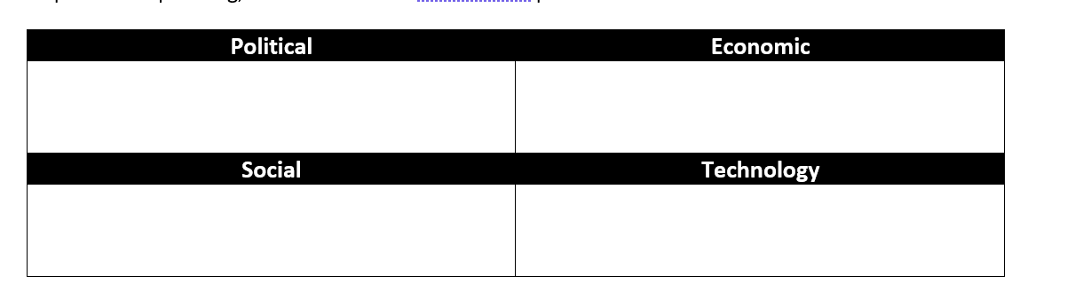

**Q4. Complete the diagram below with the five stages of risk management. Then give a brief description of each stage in the space given below:**

**……………………………………………………………………………………………………………………………………………………………….**

**……………………………………………………………………………………………………………………………………………………………….**

**……………………………………………………………………………………………………………………………………………………………….**

**……………………………………………………………………………………………………………………………………………………………….**

**……………………………………………………………………………………………………………………………………………………………….**

**……………………………………………………………………………………………………………………………………………………………….**

**……………………………………………………………………………………………………………………………………………………………….**

**……………………………………………………………………………………………………………………………………………………………….**

**……………………………………………………………………………………………………………………………………………………………….**

**……………………………………………………………………………………………………………………………………………………………….**

**……………………………………………………………………………………………………………………………………………………………….**