**1.Following are the algorithms for calculate, add, multiply and divide button.**

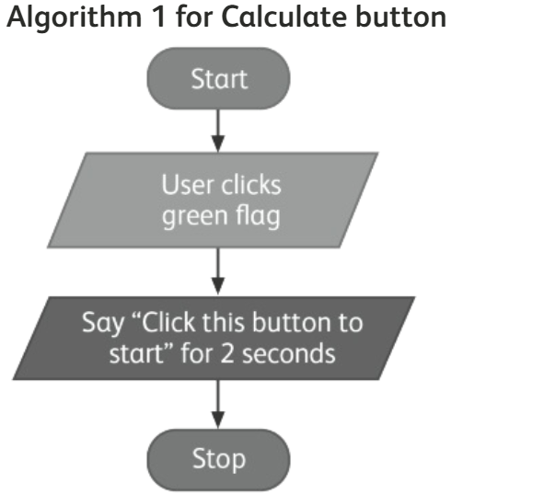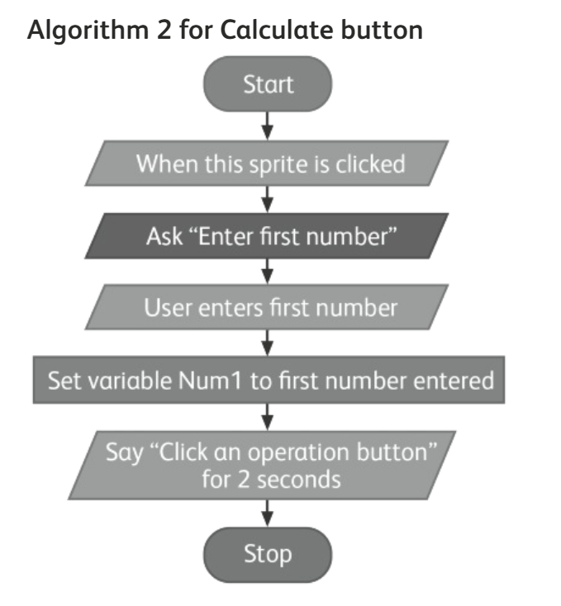

**Algorithm 3 for ADD button**

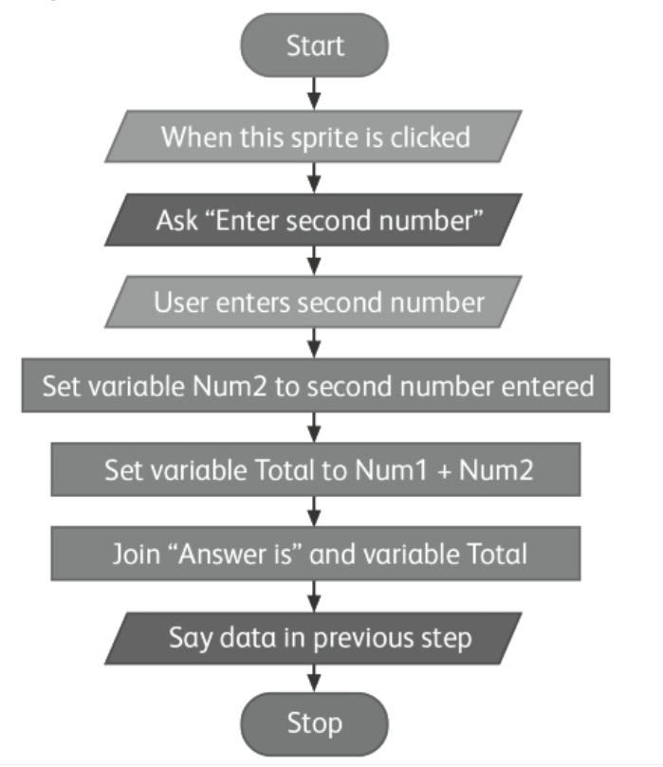

**Algorithm 3 for multiply button Algorithm 3 for divide button**

