Quiz 5- MS
Booking systems
Question | Answer | Marks
1 a  b | 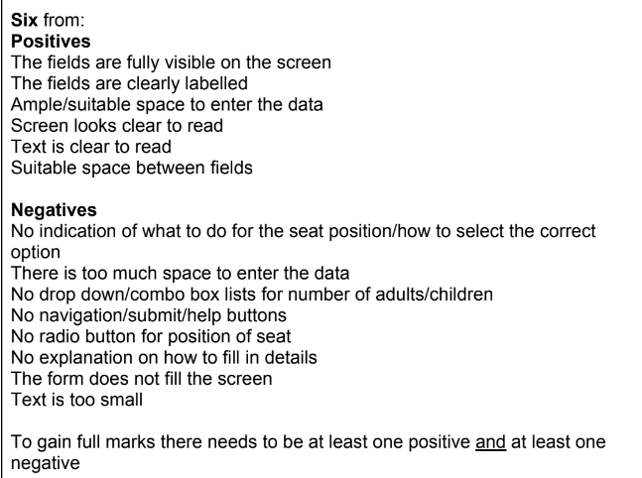  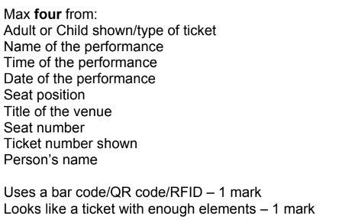 | 6  4

