**QUIZ-5 (GRADED)**

**BOOKING SYSTEMS**

1. The Fish Bowl is a large outdoor music arena. It uses an online booking system.

A customer has entered her data into the booking system using an online data entry form.

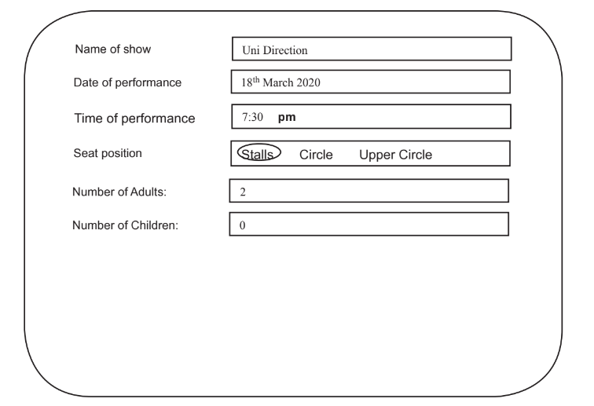

1. Evaluate this online data entry form.

………………………………………………………………………………………………………………………………………………………………………………………………………………………………………………………………………………………………………….

………………………………………………………………………………………………………………………………………………………………………………………………………………………………………………………………………………………………………….

………………………………………………………………………………………………………………………………………………………………………………………………………………………………………………………………………………………………………….

………………………………………………………………………………………………………………………………………………………………………………………………………………………………………………………………………………………………………….

………………………………………………………………………………………………………………………………………………………………………………………………………………………………………………………………………………………………………….

……………………………………………………………………………………………………………………………………………………………………………………………………………………………………………………………………………………………………..[6]

1. When a person makes a booking, a ticket will be produced for each person. The ticket will be

sent by email and can then be printed out or used on a smartphone to gain entry to the event.

Design a ticket that includes elements for both visual and electronic checking for the

forthcoming music event. [4]