**HTML CODE:**

**Title tag with 100% accurate text – 1 mark**

**Pair of html tags – 1 mark**

**Pair of head tags – 1 mark**

**Pair of body tags – 1 mark**

<html>

<head>

<title> Save Earth</title>

<h1 align = center> GLOBAL WARMING </h1>

**bgcolor – 1 mark**

**“grey” – 1 mark**

</head>

<body bgcolor = "grey">

**Inserted correct image – 1 mark**

**Accurate dimensions – 1 mark**

<img src = "C:\Users\HelenRoseVarghese\Desktop\practical 8\image1.jpg" width="500" height ="250"><br>

**3 paragraphs inserted – 1 mark**

**Paragraph 1**

**Font face = “Times New Roman” – 1 mark**

**Font size = 5px – 1 mark**

**Font color = “red” – 1 mark**

**Text alignment = justify – 1 mark**

<p align = "justify"> <font face ="times new roman" size = "5px" color="red"> Global warming, the phenomenon of increasing average air temperatures near the surface of Earth over the past one to two centuries.

**Superscript used for 20th – 1 mark**

<b><i><u>Climate</b></i></u> scientists have since the mid-20<sup>th</sup> century gathered detailed observations of various weather phenomena (such as temperatures, precipitation, and storms) and of related

influences on <b><i><u>climate</b></i></u> (such as ocean currents and the atmosphere’s chemical composition).

These data indicate that Earth’s <b><i><u>climate</b></i></u> has changed over almost every conceivable timescale since the beginning of geologic time and that human activities since at least the beginning of the Industrial Revolution have a growing influence over the pace and extent of present-day <b><i><u>climate</b></i></u> change.</font></p>

**Inserted hr tag – 1 mark**

Centre aligned – 1 mark

<hr>

**Paragraph 2**

**Font face = “Arial” – 1 mark**

**Font size = 4px – 1 mark**

**Font color = “blue” – 1 mark**

**Text alignment = left – 1 mark**

<p align = "left"> <font face ="arial" size = "4px" color="blue"> Many <b><i><u>climate</b></i></u> scientists agree that significant societal, economic, and ecological damage would result if the global average temperature rose by more than 2 °C (3.6 °F) in such a short time.

Such damage would include increased extinction of many plant and animal species, shifts in patterns of agriculture, and rising sea levels.

By 2015 all but a few national governments had begun the process of instituting carbon reduction plans as part of the Paris Agreement, a treaty designed to help countries keep global warming to 1.5 °C (2.7 °F) above preindustrial levels in order to avoid the worst of the predicted effects.

Whereas authors of the 2018 special report noted that should carbon emissions continue at their present rate, the increase in average near-surface air temperature would reach 1.5 °C sometime between 2030 and 2052, authors of the AR6 report suggested that this threshold would be reached by 2041 at the latest.</font></p>

<hr>

**Paragraph 3**

**Font face = “Comic sans MS” – 1 mark**

**Font size = 3px – 1 mark**

**Font color = “cyan” – 1 mark**

**Text alignment = centre – 1 mark**

<p align = "centre"><font face ="comic sans ms" size = "3px" color="cyan"> Human activity has influenced global surface temperatures by changing the radiative balance governing the Earth on various timescales and at varying spatial scales.

The most profound and well-known anthropogenic influence is the elevation of concentrations of greenhouse gases in the atmosphere.

Humans also influence <b><i><u>climate</b></i></u> by changing the concentrations of aerosols and ozone and by modifying the land cover of Earth’s surface.</p>

<hr>

</body

</html>

**Screenshot of the web page with address bar - 1 mark**

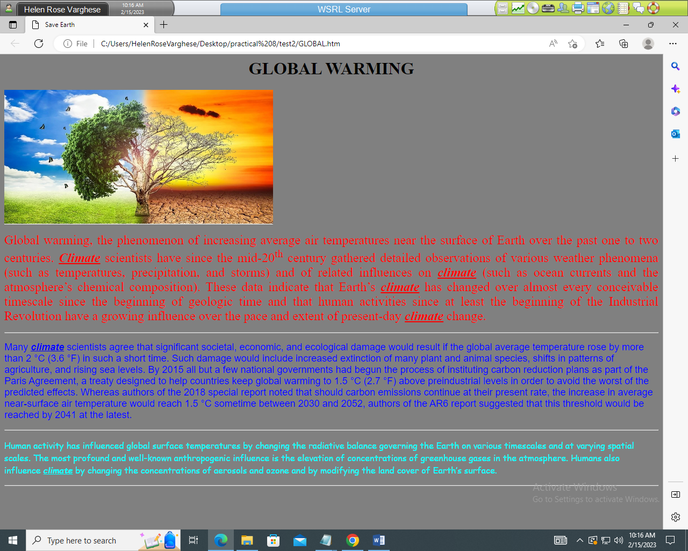

**Heading inserted with 100% accurate text – 1 mark**

**H1 style – 1 mark**

**Centre aligned – 1 mark**

**Three occurrences of the word “climate” (paragraph 1, 2 & 3) changed to**

* **Bold – 1 mark**
* **Underlined – 1 mark**
* **Italic – 1 mark**