1. (a) The chemical equation can be represented as shown.

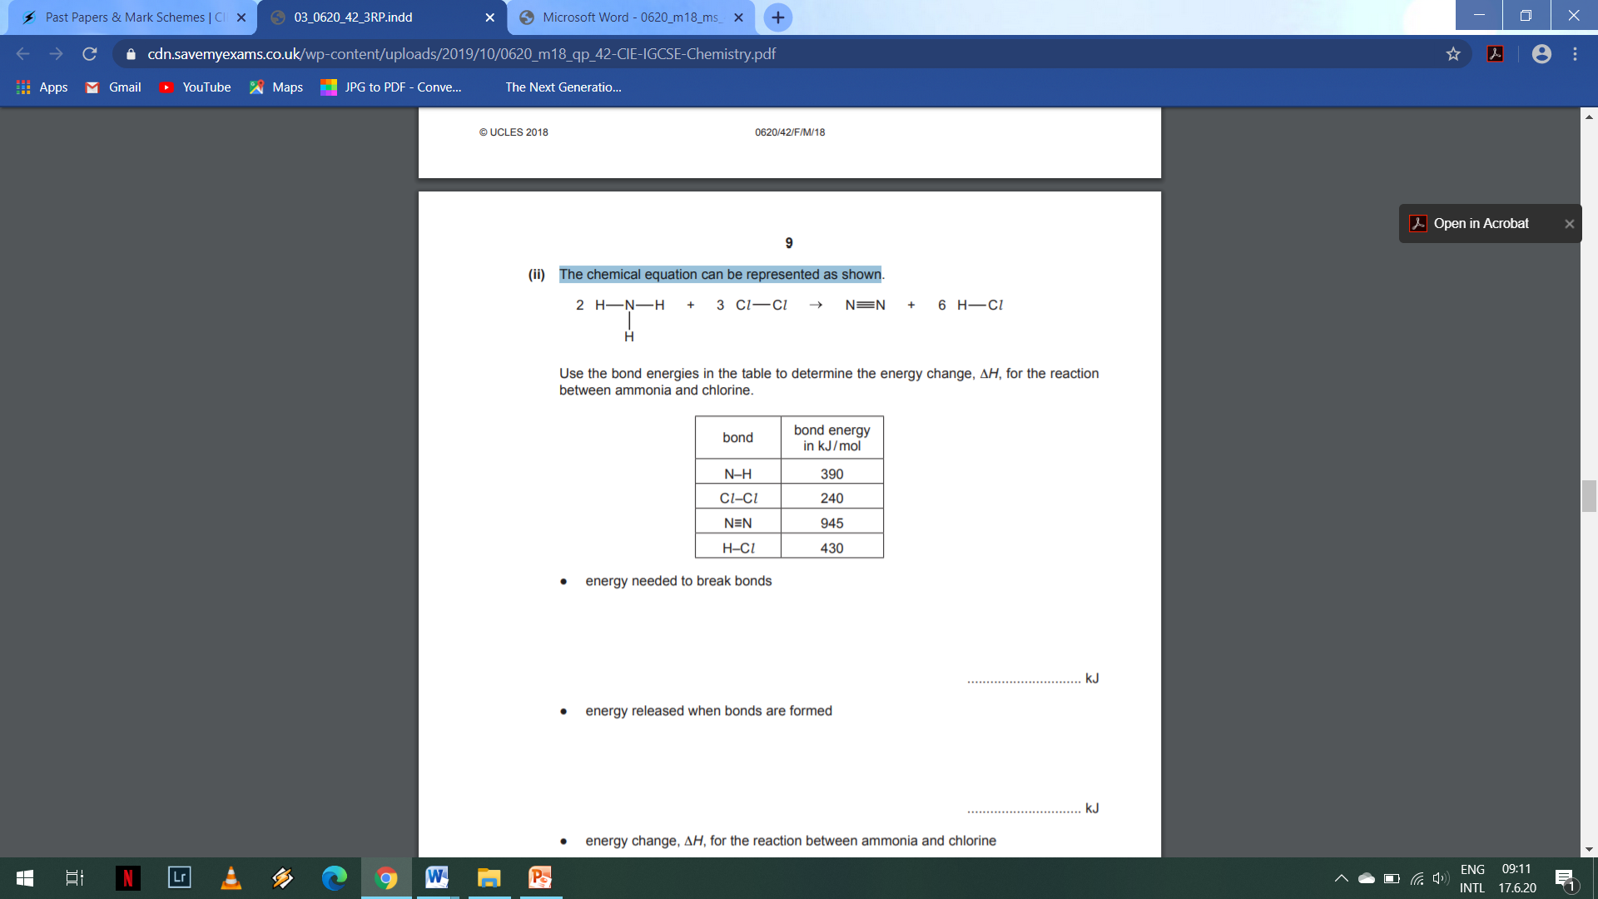

Use the bond energies in the table to determine the energy change, ΔH, for the reaction between ammonia and chlorine.

|  |  |
| --- | --- |
| Bond | Energy/ kJ per mol |
| N-H | 390 |
| C*l*-C*l* | 240 |
|  | 945 |
| H-C*l* | 430 |

* energy needed to break bonds

.............................. kJ

* energy released when bonds are formed

.............................. kJ

* energy change, ΔH, for the reaction between ammonia and chlorine

.............................. kJ [3]

(b) Is the reaction endothermic or exothermic? Explain your answer. ................................................................................................................................................................................................................ ....................................................................................................................................... [2]

TOTAL MARK: ____/5