1. Circle all the things that are a light source.

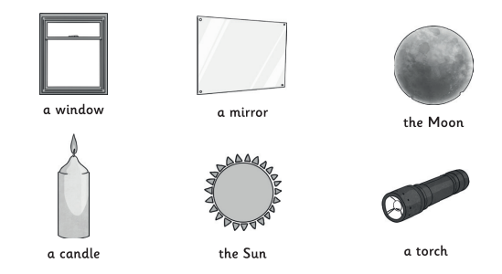

1. Join up these words to the correct explanation.

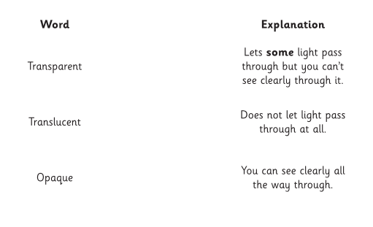

1. Explain how a shadow is formed.

___________________________________________________________________________________________________________________________________________________________________________________________________________________________________________________