**Marketing strategy**

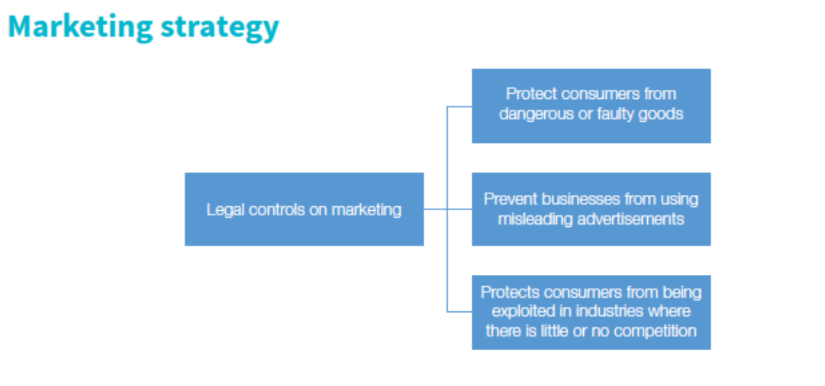

**Past paper question:**

**Q1.**

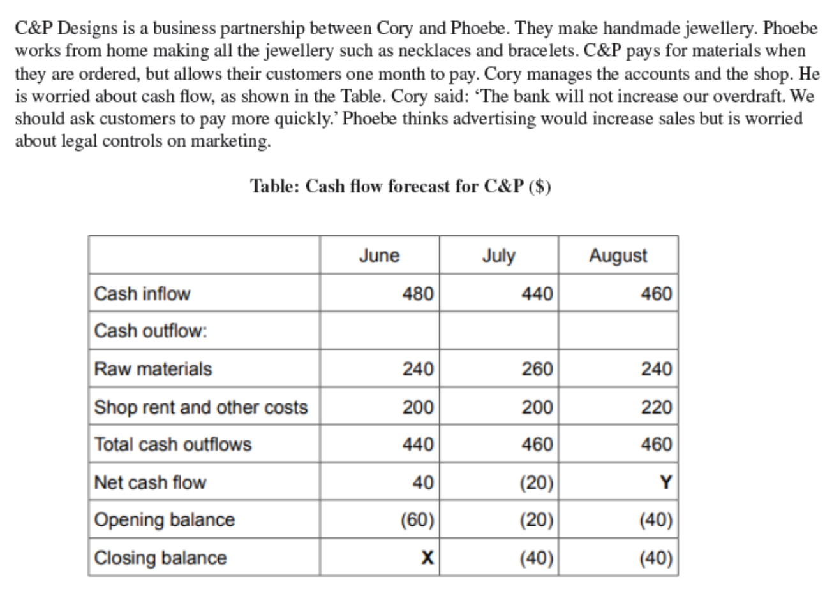

**Q2.**

**Mark scheme:Q1.**

**Mark scheme Q2.**

