**1) Research and create the PowerPoint presentation or a digital poster on encryption.**

a) Add a title slide with group member names and class.

b) 2nd, 3rd slide add information on the following by making use of research skills.

i) What is encryption?

ii) In which type of applications the encryption ae made use?

iii) How does encryption is helping us to protect the data?

c) Insert appropriate images on to the slides.

d) Apply animation and transition.

d) Save the work.

OR

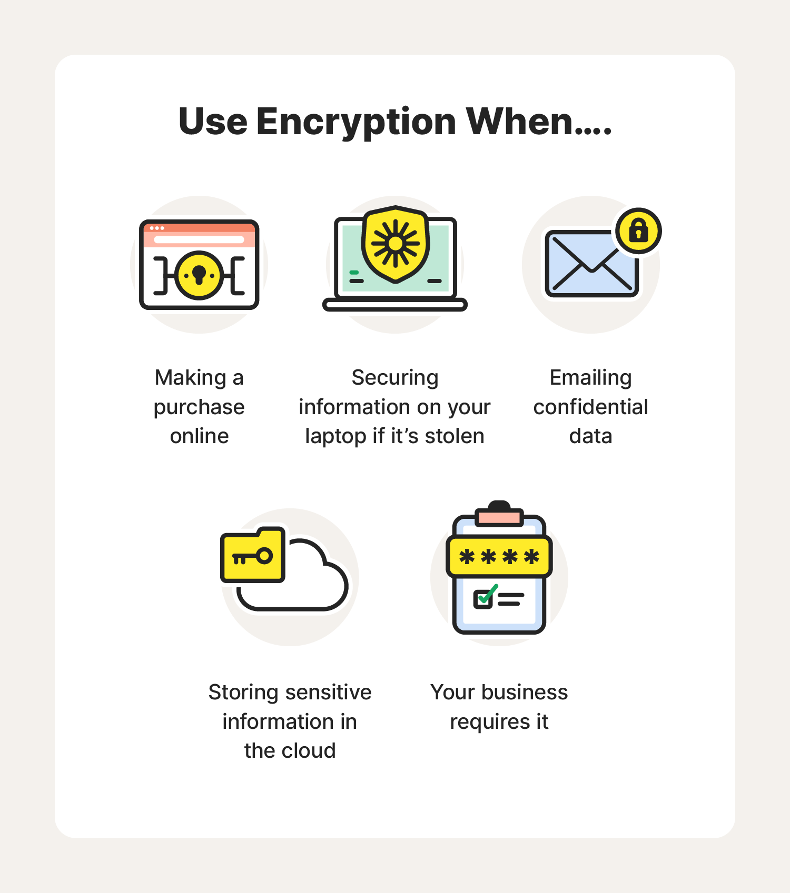

**2) For Digital poster.**

a) Open MS Word.

b) Algin the images on right and text on left.

b) Using the Times New Roam font style add the information into the document after researching about the following questions.

i) What is encryption?

ii) In which type of applications the encryption ae made use?

iii) How does encryption is helping us to protect the data?

c) Add a page border and page colour.

d) Add image effects to inserted image.

e) Save the document as Group name example Group1.

|  |  |  |  |
| --- | --- | --- | --- |
| **Rubric for ppt and poster** | | | |
|  | 1 | 2 | 3 |
| Open ppt or word |  |  |  |
| Able to research |  |  |  |
| Able to add page border, page colour. |  |  |  |
| Able to apply animation and transition |  |  |  |
| Save the document/ppt |  |  |  |
| **Key**:   1. Needs more opportunity to develop this skill. 2. Beginning to demonstrate this skill. 3. Has achieved this skill. | | | |