Quiz 1
Chapter-6(Marking Scheme)

Sl.No | Answers | Marks
1 | 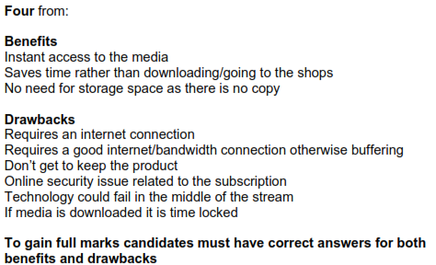 | 4
2 | 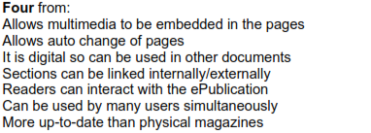 | 4
3 | RETINA SCAN  IRIS RECOGNITION  VOICE RECOGNITION | 2

