POP QUIZ

1. The table shows information about the lengths of 60 spiders

Draw a frequency polygon for the information in the table. (5)

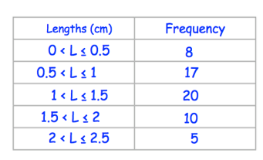

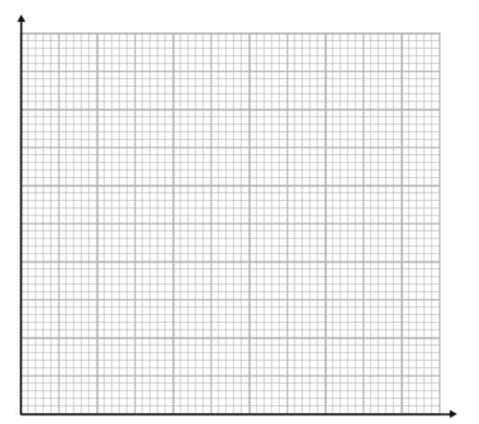

1. How many spiders have the length more than 1.5 cm?
2. How many spiders have the length less than 1cm ?
3. The frequency polygon shows the time taken for 100 boys to solve a maths question. (5)

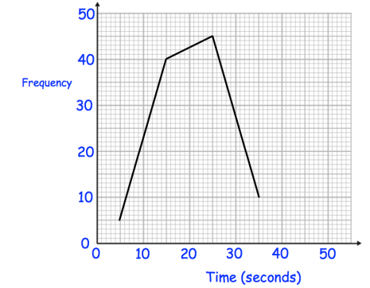

The table shows the times taken by 100 girls to answer the same question

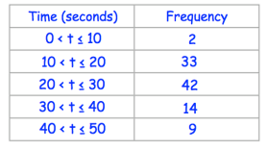

1. Draw a frequency polygon to show this information on the diagram above
2. Compare the times taken by the 100 girls and 100 boys.

