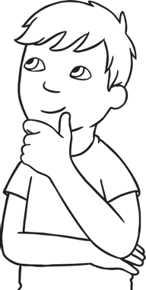

Definition How do you get to your answer?

awkward

Use the word in your own sentence. Write the antonyms of the word.



Definition How do you get to your answer?

relevant

Use the word in your own sentence. Write the antonyms of the word.



Definition How do you get to your answer?

sufficient

Use the word in your own sentence. Write the antonyms of the word.



Definition How do you get to your answer?

ancient

Use the word in your own sentence. Write the antonyms of the word.



Definition How do you get to your answer?

miserable

Use the word in your own sentence. Write the antonyms of the word.



Definition How do you get to your answer?

convenient

Use the word in your own sentence. Write the antonyms of the word.



Definition How do you get to your answer?

inadequate

Use the word in your own sentence. Write the antonyms of the word.



Definition How do you get to your answer?

peacful

Use the word in your own sentence. Write the antonyms of the word.



Definition How do you get to your answer?

coward

Use the word in your own sentence. Write the antonyms of the word.



Definition How do you get to your answer?

visible