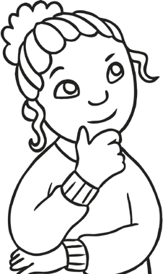

Definition How do you get to your answer?

young

Use the word in your own sentence. Write the antonyms of the word.



Definition How do you get to your answer?

rich

Use the word in your own sentence. Write the antonyms of the word.



Definition How do you get to your answer?

Wise

Use the word in your own sentence. Write the antonyms of the word.



Definition How do you get to your answer?

foolish

Use the word in your own sentence. Write the antonyms of the word.



Definition How do you get to your answer?

fantasy

Use the word in your own sentence. Write the antonyms of the word.



Definition How do you get to your answer?

narrow

Use the word in your own sentence. Write the antonyms of the word.



Definition How do you get to your answer?

silence

Use the word in your own sentence. Write the antonyms of the word.



Definition How do you get to your answer?

interesting

Use the word in your own sentence. Write the antonyms of the word.



Definition How do you get to your answer?

scare

Use the word in your own sentence. Write the antonyms of the word.



Definition How do you get to your answer?

abundant