**Task 1: Use the table and complete the spreadsheet.**

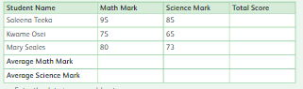

1. Enter the data in a spreadsheet.
2. Format the data with the correct Number Format: text or number.
3. Include a function to calculate the total score of each student. Use cell references.
4. In the cell next to the label **Average Math Marks**, include the function to calculate the average Math marks.
5. In the cell next to the label **Average Science Marks**, include the function to calculate the Average Science Marks.
6. Save the spreadsheet with **Your-name-Task 1.**

|  |  |  |  |  |
| --- | --- | --- | --- | --- |
| **Rubric for Spreadsheet** | | | | |
|  | 1 | 2 | 3 | Total |
| Able to enter data |  |  |  |  |
| Able to use find feature |  |  |  |  |
| Able to identify cell address |  |  |  |  |
| **Key**: 1. Needs more opportunity to develop this skill.  2. Beginning to demonstrate this skill.  3. Has achieved this skill. | | | | |

**Task 2:** **Design a questionnaire using Google Forms to collect data to determine how much money students spend at school weekly?**

a. Name of student

b. Class

c. Amount of money spent at school (weekly). The options are:

* less than $5.99
* greater than or equal to $5.99 and less than $10.99
* greater than or equal to $10.99

d. For which purpose did u spend the money.

e. How much money did you spend in canteen?

* less than $6
* greater than or equal to $7 and less than $10.99
* greater than or equal to $12.99

1. Add a design to your form.

|  |  |  |  |  |
| --- | --- | --- | --- | --- |
| **Rubric for Spreadsheet** | | | | |
|  | 1 | 2 | 3 | Total |
| Able to enter data |  |  |  |  |
| Able to use find feature |  |  |  |  |
| Able to identify cell address |  |  |  |  |
| **Key**: 1. Needs more opportunity to develop this skill.  2. Beginning to demonstrate this skill.  3. Has achieved this skill. | | | | |

**Task 3: Create the following from the below data.**

A database is being created to store product details at a supermarket.

Complete the spreadsheet table with the characteristics (data type) of the

Fields to be used.

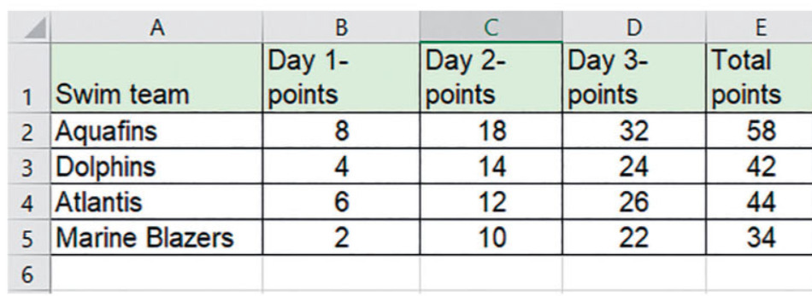 a. Enter the data in a spreadsheet as shown.

b. Find the difference between the highest number of points and least number of points.

c. Create a column chart to show the name of the swim team and the total points scored.

d. Find the average points gained by all teams on Day 2.

e. Find the Grand Total points gained by all teams.

f. Save the spreadsheet Your-task-Task 3.

|  |  |  |  |  |
| --- | --- | --- | --- | --- |
| **Rubric for Spreadsheet** | | | | |
|  | 1 | 2 | 3 | Total |
| Able to enter data |  |  |  |  |
| Able to use find feature |  |  |  |  |
| Able to identify cell address |  |  |  |  |
| **Key**: 1. Needs more opportunity to develop this skill.  2. Beginning to demonstrate this skill.  3. Has achieved this skill. | | | | |