**Encrypt the Following Messages**

1.)Caesar cipher with shift (+4)

|  |  |  |  |  |  |  |  |  |  |  |  |
| --- | --- | --- | --- | --- | --- | --- | --- | --- | --- | --- | --- |
| G | O | O | D |  | M | O | R | N | I | N | G |
|  |  |  |  |  |  |  |  |  |  |  |  |

2.) Caesar cipher with shift (-6)

|  |  |  |  |  |  |  |  |  |  |  |  |  |  |  |  |
| --- | --- | --- | --- | --- | --- | --- | --- | --- | --- | --- | --- | --- | --- | --- | --- |
| H | A | V | E |  | A |  | N | I | C | E |  | D | A | Y | ! |
|  |  |  |  |  |  |  |  |  |  |  |  |  |  |  |  |

**Decrypt the Following Messages**

3.) Caesar cipher with shift (+8)

|  |  |  |  |  |  |  |  |  |  |  |  |  |  |  |  |
| --- | --- | --- | --- | --- | --- | --- | --- | --- | --- | --- | --- | --- | --- | --- | --- |
| K | W | U | X | C | B | M | Z |  | A | K | Q | M | V | K | M |
|  |  |  |  |  |  |  |  |  |  |  |  |  |  |  |  |

4.) Caesar cipher with shift (-3)

|  |  |  |  |  |  |  |  |  |  |  |
| --- | --- | --- | --- | --- | --- | --- | --- | --- | --- | --- |
| F | P |  | X | T | B | P | L | J | B | ! |
|  |  |  |  |  |  |  |  |  |  |  |

**Find the key & Decrypt the message?**

5.) Caesar cipher with shift (__________)

*“Wnwjqtgvq kzgmdv dwsjf lg hjgyjse s ugehmlwj, twusmkw al lwsuzwk qgm zgo lg lzafc.”*

6.) Caesar cipher with shift( ________)

- lmxox chul, yhkfxk vxh tgw vkxtmhk hy tiiex

**Random Substitution Cipher**

*Directions: Use the key below to encrypt and decrypt the following messages:*

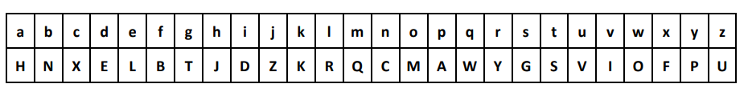

**Encrypt the Following Messages**

1. Write a short message to a friend and then using the key above, encrypt the message

Original Message __________________________________________

Decrypted Message ________________________________________

**Decrypt the Following Messages**

1. Using the key above, decrypt the following message

|  |  |  |  |  |  |  |  |  |  |  |  |  |  |  |  |  |  |  |  |  |  |  |  |
| --- | --- | --- | --- | --- | --- | --- | --- | --- | --- | --- | --- | --- | --- | --- | --- | --- | --- | --- | --- | --- | --- | --- | --- |
| Z | H | C | V | H | Y | P | N | Y | D | C | T | G |  | S | J |  | L |  | G | C | M | O | K |
|  |  |  |  |  |  |  |  |  |  |  |  |  |  |  |  |  |  |  |  |  |  |  |  |