Worksheet 11.4
1
Name and structure of monomer | Name and structure of polymer
Ethene  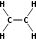 | Poly(ethene)  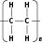
Chloroethene | Poly(chloroethene)  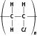
Phenylethene  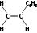 | Poly(phenylethene)  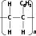
2 A monomer is the simple molecule that then is joined together into a long-chain polymer / the individual unit from which a polymer is built.
3 They have a carbon–carbon double bond (C=C).
4 It does not corrode / it is lighter.
5 a It is flexible and an electrical insulator.
b It does not perish / poly(chloroethene) is fire resistant / it can be made in a variety of colours.
6 tetrafluoroethene poly(tetrafluoroethene), PTFE
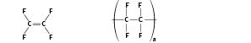
7 These addition polymers are non-biodegradable and therefore do not rot. They give off toxic fumes when incinerated (burnt).

