Revision worksheet 4

1. Name 3 things that you can do in a second.

____________________________________________________________

1. Name 3 things that you can do in a minute or in a few minutes.

_____________________________________________________________

1. Draw a line to match the time on digital and analogue clock.

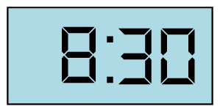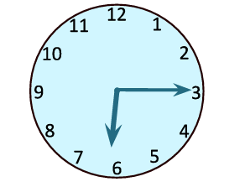

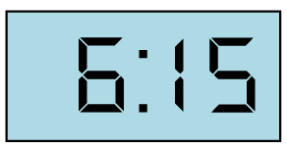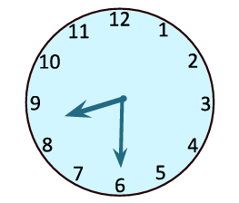

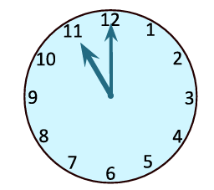

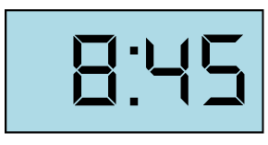

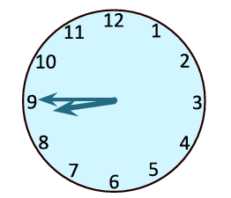

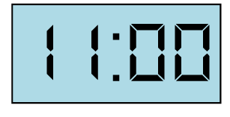

1. Write the time in words under each clock.

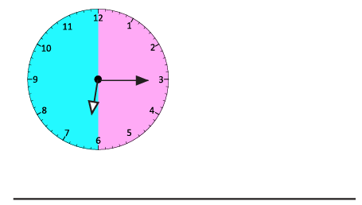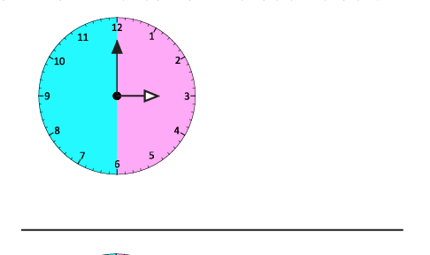

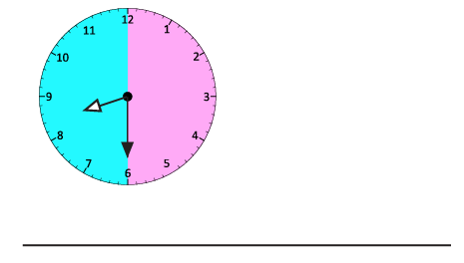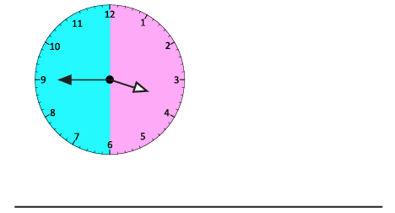

1. 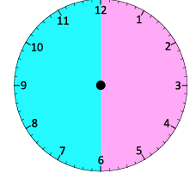Look at these clocks. What time it will be after half an hour? Show your answer by drawing hands on the second clock.

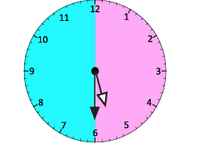a)

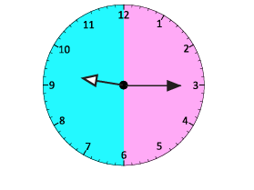

b)

1. Draw the hands on the clock faces and write the digital time.

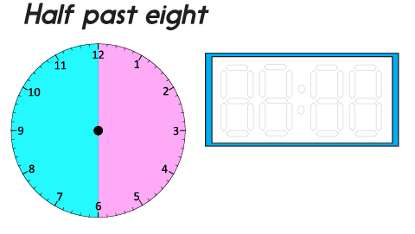

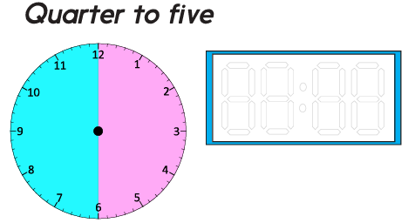

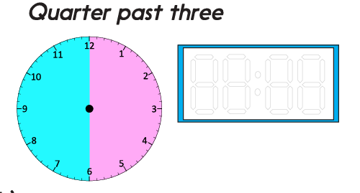

Teacher’s Signature:______________________ Parent’s Signature:________________