**Setting up a new enterprise**

**Franchise**

**Starter activity:**

|  |  |
| --- | --- |
| **Key terms** | **Definition** |
| Franchise |  |
| franchisee |  |
| franchisor |  |

**Support notes**

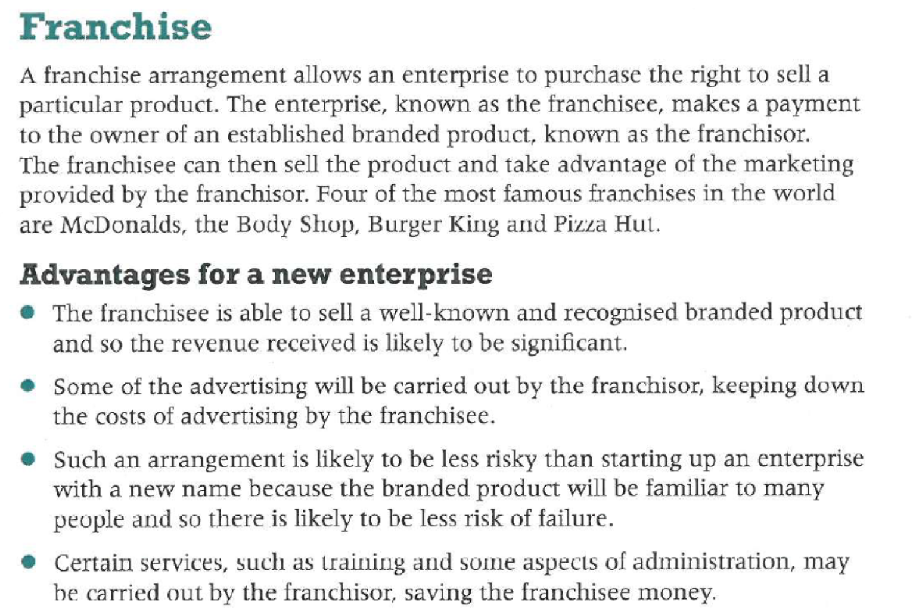

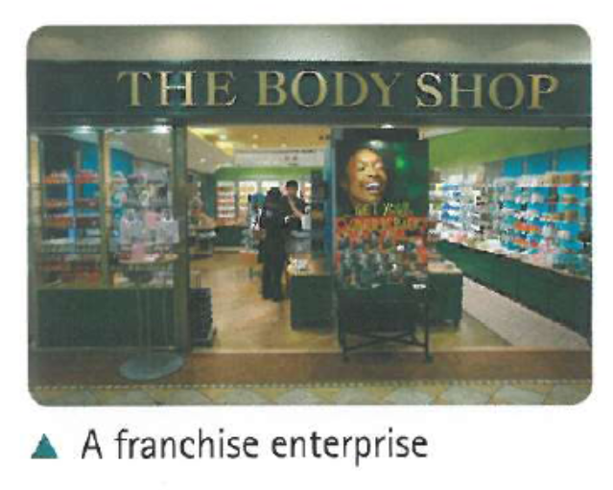



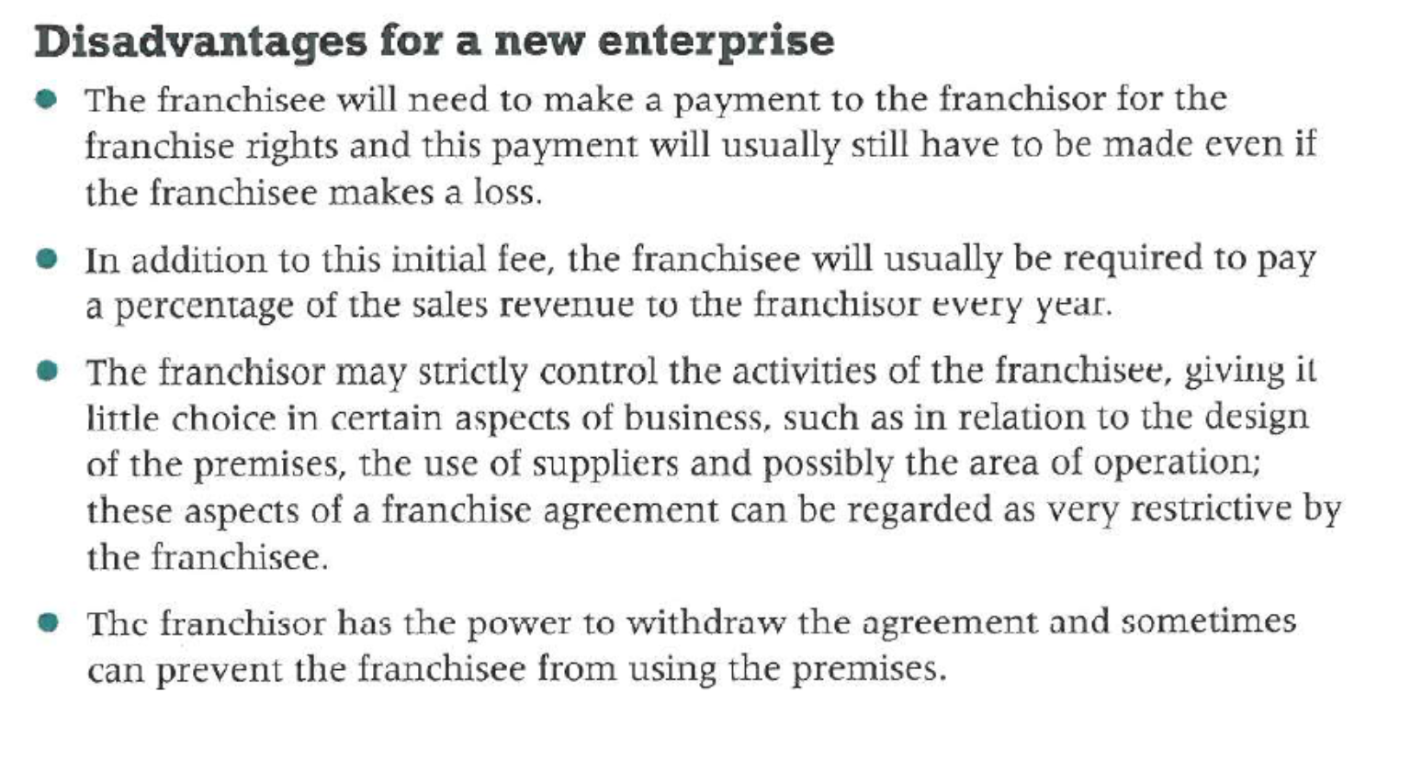

**Practice Activity:**

















































