Formal Formative 2 **25 marks**

I. Classifying /6

1. **Classify each one of these forces as a push or a pull.**
2. Gravity is a __________________ .
3. Opening a door by moving it towards you is a __________________ .
4. Closing a door by moving it away from you is a __________________ .
5. **Classify each of these materials as magnetic or non-magnetic.**
6. Copper is __________________ .
7. Aluminium is __________________ .
8. Iron is __________________

II. Labelling force diagrams /6

1. **The force diagrams below show a scooter at rest and a scooter with a boy riding it.   
    Label the forces A–E.**

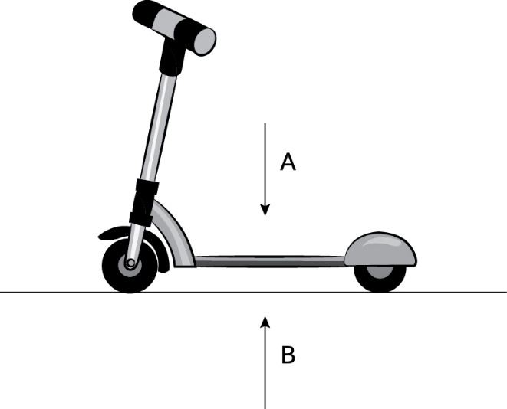

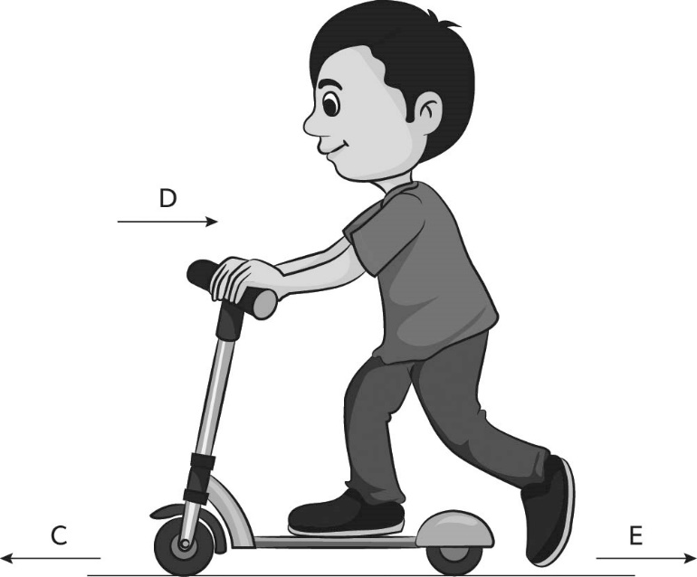

III. **Circle the best answer: /5**

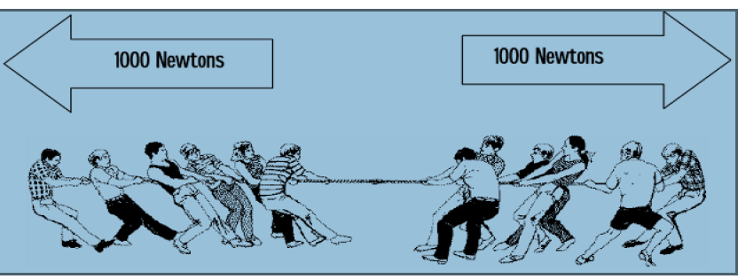

1. The forces shown above are **PUSHING / PULLING** forces.
2. The forces shown above are **WORKING TOGETHER / OPPOSITE FORCES.**
3. The forces are **EQUAL / NOT EQUAL.**
4. The forces **DO / DO NOT** balance each other.
5. The resultant force is **1000 N TO THE RIGHT / 1000 N TO THE LEFT /ZERO.**
6. There **IS / IS NO motion**.
7. **Your job is to plan a fair test for the group to compare the strength of different magnets.   
   Use the idea in the picture to help you decide what to do. /4**

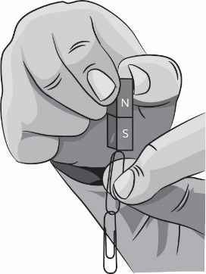

1 How will you make the test fair?

_________________________________________________________________________________

_________________________________________________________________________________

2 Why should you use a new set of paperclips to test each magnet?

_________________________________________________________________________________

_________________________________________________________________________________

1. If two forces are the **same size** and are in the **opposite directions**, they are **………………………… /4**

