QUIZ-4
Spreadsheets(Marking Scheme)

Sl.No | Answers | Marks
1.a | 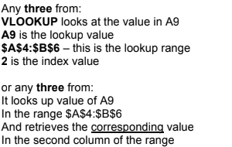 | 2
1.b |  | 1
1.c | 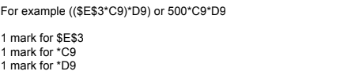 | 3
1.d | 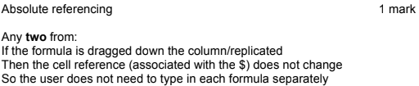 | 2
1.e | 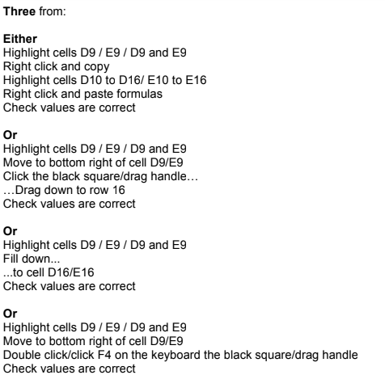 | 2

