**QUIZ-4**

**SPREADSHEETS (GRADED)**

1. The Ocean Sailing Company offers the experience of sailing on a yacht. Customers can choose which type of yacht they want to sail on. The owner keeps a spreadsheet to calculate the cost to customers. The owner allocates a loyalty code to each customer. Each code has a different discount.

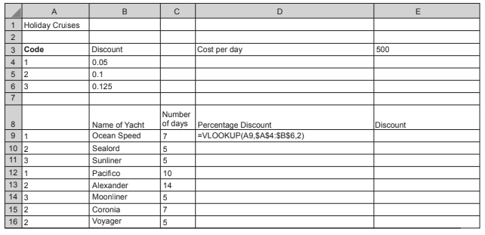

1. Explain each element of the formula in cell D9.

.........................................................................................................................................................

.........................................................................................................................................................

.........................................................................................................................................................

.........................................................................................................................................................

.........................................................................................................................................................

....................................................................................................................................................[2]

1. Identify the value you would expect to see in cell D9.

.........................................................................................................................................................

.....................................................................................................................................................[1]

1. The Discount is the cost per day multiplied by the number of days multiplied by the Percentage Discount.

Write a formula that would be entered in cell E9 to calculate the Discount.

.........................................................................................................................................................

.........................................................................................................................................................

.....................................................................................................................................................[3]

1. The $ symbol is used in the formula in cell D9.

Name this type of referencing and explain why it is used.

.........................................................................................................................................................

.........................................................................................................................................................

.........................................................................................................................................................

.........................................................................................................................................................

.........................................................................................................................................................

....................................................................................................................................................[2]

1. The Ocean Sailing Company owns a number of yachts.

Explain how you could replicate the formulae to calculate the Percentage Discount and the

Discount for each yacht.

.........................................................................................................................................................

.........................................................................................................................................................

.........................................................................................................................................................

.........................................................................................................................................................

.........................................................................................................................................................

....................................................................................................................................................[2]