1. **Choose the correct option.** **[1.5]**
2. A _________________ detector is used in smart security systems to detect the movement of an object.

**a) Light**

**b) Motion**

**c) None of these**

1. Which kind of sensors are used in farms and the food industry, to monitor soil moisture and the condition of stored food.

**a) Smart thermostats**

**b) Smart weather data loggers.**

**c) None of these**

1. A device that can broadcast and receive signals is called ___________
2. **Antenna**
3. **ISP**
4. **Cellular network**
5. **Match the following [1.5]**

|  |  |
| --- | --- |
| **5)** Input | **a)** Toast that has been toasted for the required amount of time. |
| **6)** Process | **b)** A dial on the side of the toaster. |
| **7)** Output | **c)** The toaster converts the input dial position into the toasting time. |

1. **Answer the following questions.**

4) How **smart street light systems** contributes to achieve the sustainability? **[2]**

Let the students come up with their answers.

**5) Smart thermostats are used to control smart appliances such as air conditioner unit, boilers, heaters and radiators. [1.5]**

Write down the names of any three places where we can use this device.

1. Homes
2. Offices
3. Industries

**6) Each packet that is sent over the internet includes four essential parts.**

**Name each part that is connected with each part. [2]**

1. Sender’s IP address
2. Receiver’s IP address
3. The Sequence of the packets
4. The payload

**7) In many places internet has become an important part of everyday life.**

**Any disruption may affect many people in different ways. [4]**

Write down any two problems may arise due to internet disruption in the following areas.

**IN BANKS:**

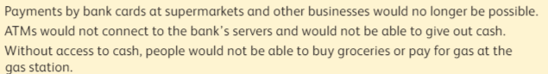**TRANSPORT SYSTEM:**

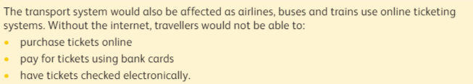**8) State whether the statements are true or false. [2]**

1. Mobile phones can be used to make phone calls while on a train. ( True )
2. All data packets that comprise the small email are transmitted along the same path to the destination computer. ( False )
3. Data can be entered using sensors. ( True )
4. A speaker is an output in audio production. ( True )

**9) Write any two things can you cannot do using house phone. [2]**

1. Let the students come up with their solution.

**10) Artificial intelligence is all around us.**

How artificial intelligence has its impact on employment? How human jobs will be effected by Artificial intelligence. **[1.5]**

Let the students come up with their solution.

**11) Write an algorithm to calculate the sum of two numbers.**

**Display the total also.**

