1. Select the best answer and show what you know. /4
2. **Why do eggs need to stay warm to hatch?**  
   a) So they can stay clean  
   b) To keep the chick comfortable  
   c) Because warmth helps the chick grow inside the egg  
   d) So the egg doesn't crack
3. **What is inside an egg before it hatches?**  
   a) A baby chick  
   b) A seed  
   c) A fish  
   d) A flower
4. **How long does it usually take for a chick to hatch?**  
   a) 1 day  
   b) 21 days  
   c) 5 minutes  
   d) 1 year
5. **If you were stranded on an island, what is the first thing you should look for?**  
   a) Toys to play with  
   b) A place to hide  
   c) Food and water  
   d) A comfy place to sleep
6. Find the adult animal and their young. /4

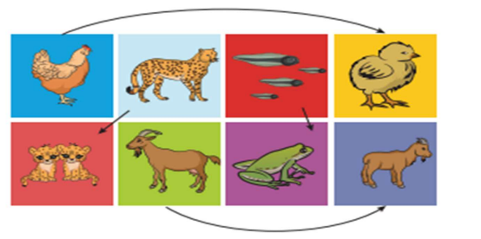

1. Which of these foods are healthy? Name any two healthy and two unhealthy foods. /4

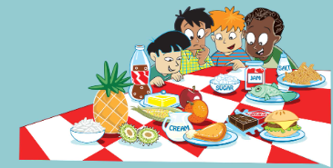

|  |  |
| --- | --- |
| **HEALTHY** | **UNHEALTHY** |
| Fruits, sweetcorn, chicken, fish | Cola, salt, jam, burger, cream, chocolate |
|  |  |

1. Which of these is exercise? Circle the exercise and cross the ones which is not an exercise. /5

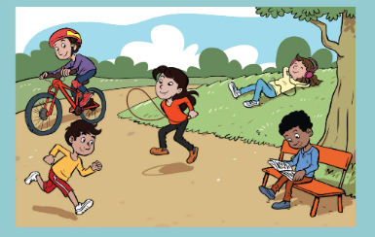Exercise – Running, riding bicycle, skipping

Not an exercise – reading, listening to music

1. Read the clues and complete the words. /3
2. Do this everyday to keep your body healthy.

|  |  |  |  |  |  |  |  |
| --- | --- | --- | --- | --- | --- | --- | --- |
|  | X |  | R | C |  | S |  |

1. This word means the food a person eats.

|  |  |  |  |
| --- | --- | --- | --- |
| M |  |  | L |

1. Your skin does this when it gets hot.

|  |  |  |  |  |
| --- | --- | --- | --- | --- |
| S |  | E | A |  |

Answer

1. EXERCISE
2. MEAL
3. SWEAT

Teacher’s Signature _________ Parent’s Signature ___________