**Show not tell**

Show not tell is a way of bringing to life our writing so that the reader can visualise what we are describing.

For example: Instead of writing **‘she was cold’** describe how she is acting – her facial expression, her actions, how her body responds.

**Sarah pulled her collar up, tightened her scarf, pushed her hands deeper into her pockets and turned her face away from the biting wind.**



**Tell: He was tired.**

**Show: Bob yawned loudly and stretched his arms out slowly. He let out long drawn out sigh. Bleary eyes stared back at him from his bedroom mirror.**

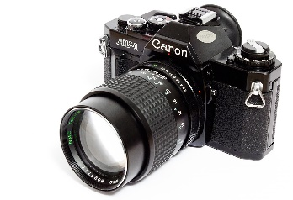

[This Photo](https://en.wikipedia.org/wiki/Canon_AV-1) by Unknown Author is licensed under [CC BY-SA](https://creativecommons.org/licenses/by-sa/3.0/)

Think: What can the camera see?

Tell: He was very sad

Show: ___________________________________________________________________________________________________________________________________________________________________________

Tell: The students were bored.

Show: ___________________________________________________________________________________________________________________________________________________________________________

Tell : It was late autumn.

Show: __________________________________________________________________________________________________________________________________________________________________________

Use sensory detail

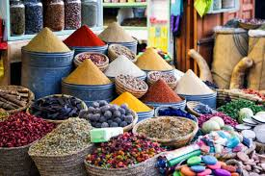Tell: Layla walked through the market.

Show: Layla walked through the street as if through a dream. Spicy cinnamon and rich coffee rode the air as she ran her fingers down silken tassels and through powdery barrels of golden saffron.

Tell: Mike climbed up the mountain.

Show: _________________________________________________________________________________________________________________________________________________________________________________

Telling Sentence

It was an unusual cat.

**Showing Sentence**

**…………………………………………………………………………………………………………………………………………………………………………………………………………………………………………………………………………………………………………………………………………………………………………………………………………………………………………………………………………………………………………………………………………………………………………………………………………………………………………………………………………………………………………………………………………………………………………………………………………………………………………………………………………………………………………………………………………………………………………………………………………**

**Telling Sentence**

**The pizza was delicious.**

**Showing Sentences:-**

**…………………………………………………………………………………………………………………………………………………………………………………………………………………………………………………………………………………………………………………………………………………………………………………………………………………………………………………………………………………………………………………………………………………………………………………………………………………………………………………………………………………………………………………………………………………………………………………………………………………………………………………………………………………………………………………………………………………………………………………………………………**