**Choose the best answer: /5**

1. There are total _______ Qalqala letters in Quranic Tajweed

1. Two
2. Three
3. Five

2. Which of the following are the lip letters?

1. Meem, Waao, Laam
2. Meem, Waao, Faa
3. Seen, Zaaae, Meem

3. How many heavy letters are there in Quraic Tajweed?

1. Six letters
2. Seven letters
3. Ten letters

4. Identify the Qalqala letters?

1. Qaaf, Tuaa, Baa, Jeem, Daaal
2. Kaaf, Laam, Meeem, Noon, Waao
3. Alif, Waao, Yaaa, Faa, Meem

5. Identify the Heavy letters?

1. Sheen, Raa, Baa, Jeem, Daaal, Faa, Meem
2. Khua, Suaad’, Duaad’, ghayn , Tuaa’, Qaaf, Zua
3. Alif, Meeem, Noon, Waao, Alif, Waao, Yaaa

________________________________________________________

**Answer the following questions with detailed sentences. /10**

1. Why do you know about the Qalqala Letters? /2

________________________________________________________________________________________________________________________________________________________________________

1. Identify and encircle the LIP LETTERS and write three words in given space: /3

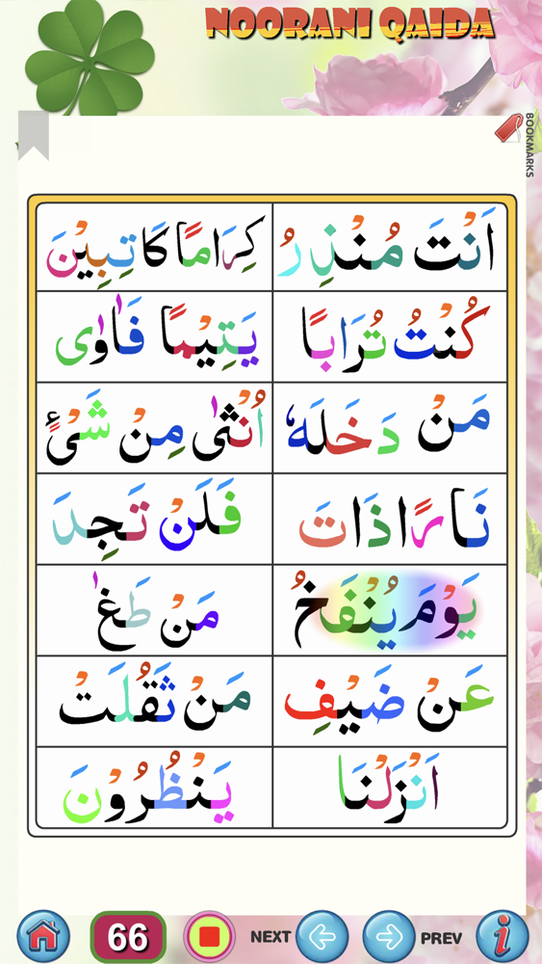

_______________________________________________________________________________________________________________________________________________________________________

3. Identify and encircle the Heavy LETTERS and write five of these words in given space: /5 /5? /2 

________________________________________________________________________________________________________________________________________________________________________

________________________________________________________________________________________________________________

________________________________________________________