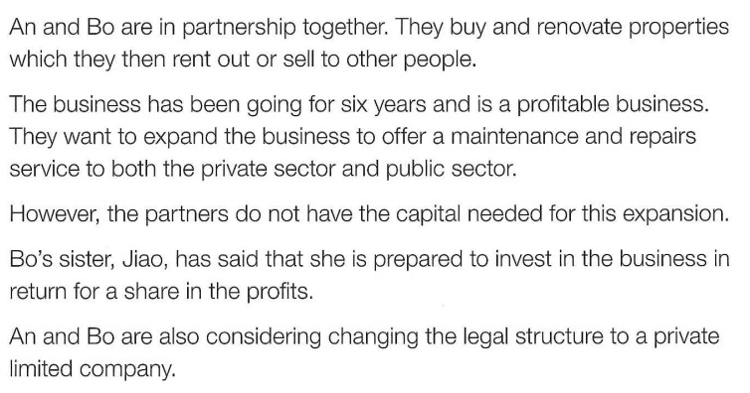
Formal Formative 1

- Identify two features of private sector organisations.
- Owned by private individuals. Financed by private individuals or through borrowing. Controlled by private individuals. Main objective to earn profit for owners. [2]
- What is meant by public sector?
b Organisations that are financed and owned by the state and controlled by government. [2]
- Identify and explain two disadvantages to An and Bo of being a partnership.
Unlimited liability (1): An and Bo personally liable for debts of business, if business fails both An and Bo would have to use personal wealth to pay off debts (1). Lack of business continuity (1): if either An or Bo decide to leave partnership, business will no longer exist (1). [Total: 4]
- Identify and explain two benefits to An and Bo of expanding their business.
Spreads risk (1): if property renovation element of business not doing well they will still earn revenue from property maintenance (1). Increase revenue/profit (1): entering new segment of market increases opportunity to increase sales (1). Economies of scale (1): as business grows they could benefit from bulk-buying discounts, etc. (1) [Total: 6]
- Do you think the partners should become a private limited company? Justify your answer.
Explanation of advantages of private limited company, e.g. limited liability, access to more capital from investors, continuity of business if one of owners leaves/dies (2). Explanation of disadvantages, e.g. sharing profits with other owners, possible loss of control, legal formalities in setting up private limited company (2). Decision based on evaluation of advantages/disadvantages of private limited company for An and Bo (2). [Total: 6]

