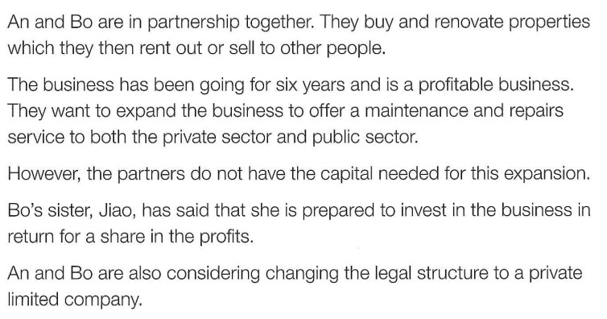
Formal Formative 1

- Identify two features of private sector organisations.
…………………………………………………………………………………………………………………………………………………………….
…………………………………………………………………………………………………………………………………………………………….……………………………………………………………………………………………………………………………………………………… [2]
- What is meant by public sector?
…………………………………………………………………………………………………………………………………………………………….
…………………………………………………………………………………………………………………………………………………………….……………………………………………………………………………………………………………………………………………………… [2]
- Identify and explain two disadvantages to An and Bo of being a partnership.
Advantage 1: …………………………………………………………………………………………………………………………………………………………….
Explanation:
…………………………………………………………………………………………………………………………………………………………….…………………………………………………………………………………………………………………………………………………………….
…………………………………………………………………………………………………………………………………………………………….Advantage 2: …………………………………………………………………………………………………………………………………………………………….

Explanation:
…………………………………………………………………………………………………………………………………………………………….…………………………………………………………………………………………………………………………………………………………….……………………………………………………………………………………………………………………………………………………… [4]
- Identify and explain two benefits to An and Bo of expanding their business.
Benefit 1: …………………………………………………………………………………………………………………………………………………………….
Explanation:
…………………………………………………………………………………………………………………………………………………………….…………………………………………………………………………………………………………………………………………………………….
……………………………………………………………………………………………………………………………………………………………. Benefit 2: …………………………………………………………………………………………………………………………………………………………….
Explanation:
…………………………………………………………………………………………………………………………………………………………….…………………………………………………………………………………………………………………………………………………………….………………………………………………………………………………………………………………………………………………………. [6]
- Do you think the partners should become a private limited company? Justify your answer.
…………………………………………………………………………………………………………………………………………………………….…………………………………………………………………………………………………………………………………………………………….…………………………………………………………………………………………………………………………………………………………….…………………………………………………………………………………………………………………………………………………………….…………………………………………………………………………………………………………………………………………………………….…………………………………………………………………………………………………………………………………………………………….…………………………………………………………………………………………………………………………………………………………….…………………………………………………………………………………………………………………………………………………………….…………………………………………………………………………………………………………………………………………………………….…………………………………………………………………………………………………………………………………………………………….………………………………………………………………………………………………………………………………………………………. [6]

