1. **Select the correct option. 7 marks**
2. 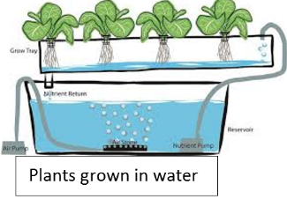What type of gardening technique is shown in the picture.
3. Hydroponics
4. Soil planting
5. none of the above.
6. **What is a garden centre?**  
   a) A place where you play with toys  
   b) A place where you can buy plants and tools to grow your own garden  
   c) A place where you watch TV
7. **What should you put in the pot first before planting the seeds?**  
   a) Rocks  
   b) Soil  
   c) Water
8. **Why do plants need sunlight?**  
   a) To stay warm  
   b) To help them make their own food  
   c) To play with it
9. **What happens if we don’t water the plants?**  
   a) They will grow faster  
   b) They will not grow or could dry out  
   c) They will turn into toys
10. **Where should we place our plants to help them grow?**  
    a) In a dark room  
    b) By a window where there is sunlight  
    c) Inside a drawer
11. **What do plants need to grow?**  
    a) Sunlight, water, and air  
    b) Toys and candy  
    c) Blankets and pillows

1. **Circle true or false. 3 marks**
2. **Putting plants in a dark place will help them grow faster.** (True / False)
3. **You can plant seeds in both soil and water.** (True / False)
4. **Too much water can spoil the plant.** (True / False)