**QUIZ**

**Stem and leaf diagram**

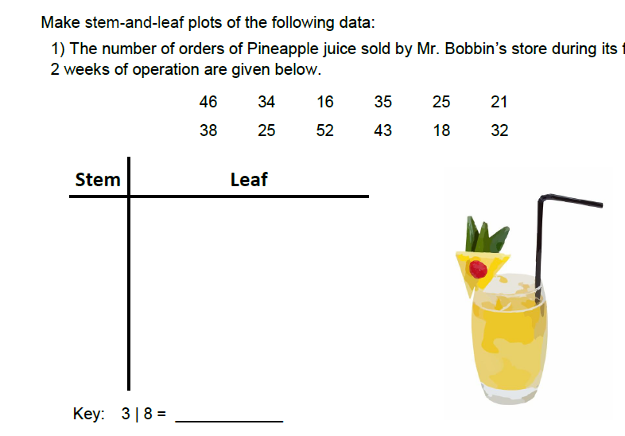

**(2)**

**(1)**

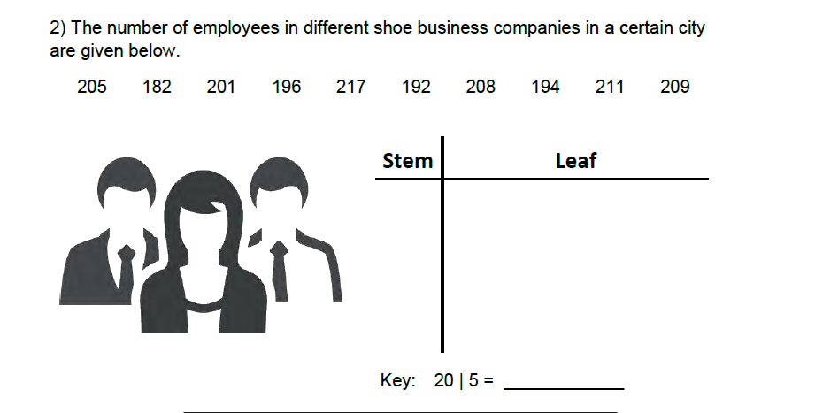

**(2)**

1. Here are the ages of 14 adults (2)

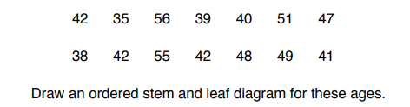

1. Helen plays darts. Here are her scores. (4)

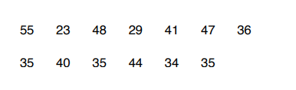

1. Draw an ordered stem and leaf diagram to show her scores
2. Write down the mode.
3. Work out the range.