**Station 1**

1. . Here are the lengths in mm of 15 earthworms

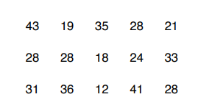

1. Complete an ordered stem and leaf diagram to show this information
2. How many earthworms are over 40 millilmetres?
3. Write down the mode.
4. What fraction of the earthworms are under 20 millimetres?

**Station 2**

1. The number of people visiting a cafe each day, for 11 days, is listed below.



1. Complete an ordered stem and leaf diagram for this information. A key has been included.

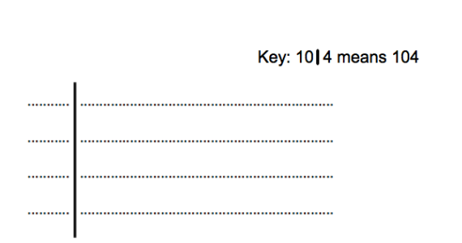

1. Write down the mode.
2. Write down the range.
3. The table shows information about the time taken for teachers to travel to work. Draw a frequency polygon for the information in the table.

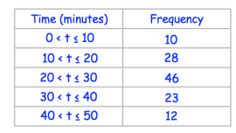

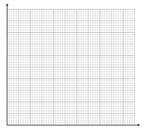

**Station 3**

1. The table gives information about the income of 200 households in a village.

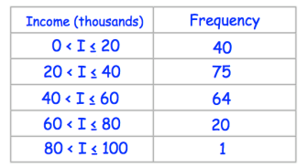

1. Draw a frequency polygon for the information in the table.

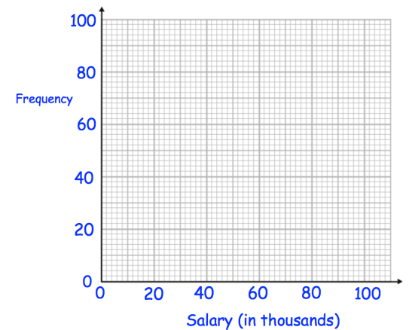

1. **How many people have the salary more than 40 thousands**
2. **How many people have the salary less than 40 thousands**
3. **The salary of a person is 40 thousand. Between which interval will it be counted ?**

**Or**

** **