Revision worksheet 2

1. Continue these patterns. Starting with the number below and writing a number in each box.

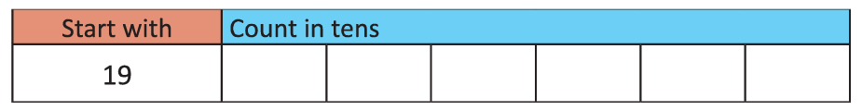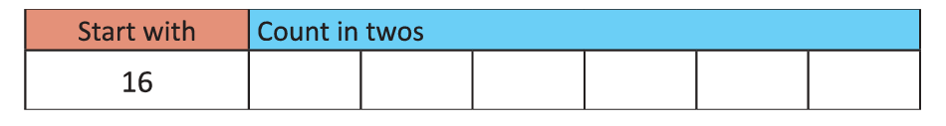

1. At the fruit shop, all these fruits are half the price, write the new price in the space given.



16 p

# Half Price: ___________________

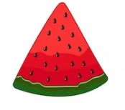

Half Price: ___________________

18 p

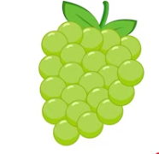

Half Price: ___________________

26 p

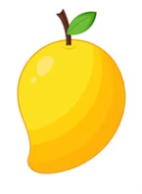

Half Price: _____________________

30 p

1. All the shirts are double price now. Write the new price



18 p

Double price: ____________________

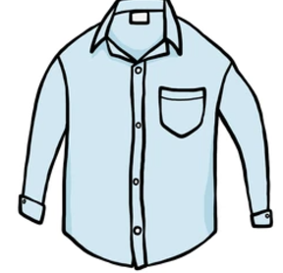

12 p

Double price: ____________________

1. Draw the number of 10 p coins needed to pay for these items.

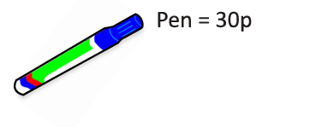

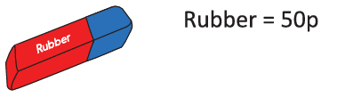

1. Draw the number of 2 p coins needed to pay for these items.

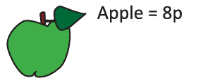

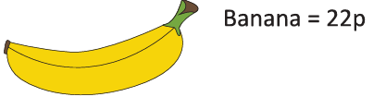

1. Complete these statements.



# Half of 14 is _______,

So, Double ________ is ________.



Half of 24 is _______.

So, Double ______ is _______.

1. Count on in 2’s

3, 5, 7, 9, ______, ______, _____

1. Count on in 10’s

17, 27, ______,________, 57

1. Write the repeated addition number sentences for each multiplication sentence.

a) 5 × 5 = 25 _______________________________________

b) 4 × 2 = 8 _______________________________________

c) 4 × 3 = 12 _______________________________________

1. How many flowers in 3 bouquets? Write your answer in the form of a multiplication number sentence.



________________________________________________________

Teacher’s Signature:______________________ Parent’s Signature:________________