Activity 1

Clara follows this path to her house.

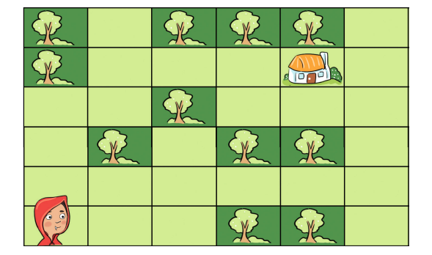

Complete the algorithm for Clara. Choose the correct numbers to fill in the blanks for Steps 4 and 5.

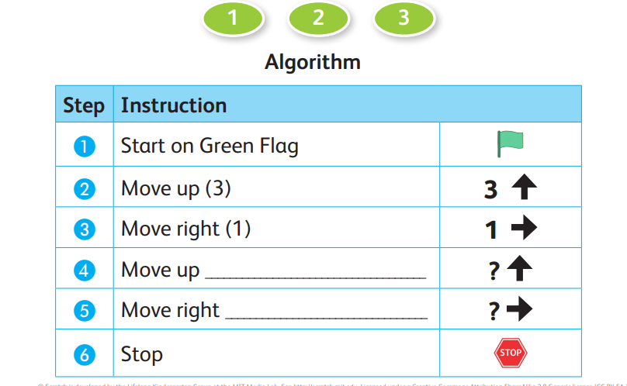

Activity 2: Create the program in ScratchJr.

Open ScratchJr.

Add a Background .

Add the Crab character.

Add the blocks of code you chose in question Activity 1.

Run the program.

