# Encircle the correct answer. /2

* 1. The physical parts that make up a computer is called a

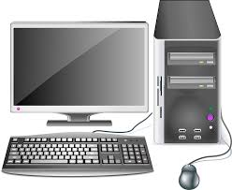

|  |  |
| --- | --- |
| a) System ware | b) Software |
| c) Hardware | d) Computer ware |

* 1. Which of the following is not an example of software.

|  |  |
| --- | --- |
| Buy Microsoft Word (PC or Mac) | Cost of Word Only or with Microsoft 365a) | Canon imagePROGRAF PRO-1000 17" Professional Photographic Inkjet Printer  (13803257601) | Bedfords.comb) |
| What is Scratch Programming - Teaching Wiki - Computingc) | The advantages of using Google Chrome - Get Chrome OS Linuxd) |

* 1. Hardware includes:

|  |  |
| --- | --- |
| a) input devices | b) output devices |
| c) storage devices | d) all of them |

* 1. Which of the following devices are automatic input device?

|  |  |
| --- | --- |
| a) | Das Keyboard - The Ultimate Mechanical Keyboard Experience for Overachieversb) |
| TKGOU USB Microphone for PC - Mute Button & LED Qatar | Ubuyc) | d) |

# Write (true) if the sentence is correct and (false) if it is not. /2

1. Biometric devices identify a person based on features of their body.

__________

1. Over time, computer hardware may suffer damage.
2. Devices that can enter data without humans are called manual devices.
3. There are two categories of hardware for a working computer. ___________

# Fill in the blanks with the help of the words given in the box. /2

**fingerprint interaction face automatic**

1. When Asma looks at her phone, it scans her to unlock.

However, Abdul said he uses his . This is called

______________________ data input, where data is entered into the computer using little or no human .

1. **Write any two differences between hardware and software.** **/2**

|  |  |
| --- | --- |
| **Hardware** | **Software** |
| 1) | 1) |
| 2) | 2) |

1. **Below are the two categories of input devices: manual and automatic.**

**Classify the devices under the appropriate group.**  **/4**

|  |  |  |  |
| --- | --- | --- | --- |
| Mouse | RFID | Keyboard | Fingerprint reader |
| Sensors | Digital camera | joystick | QR codes |

|  |  |
| --- | --- |
| Manual Input Device | Automatic Input Device |
|  |  |
|  |  |
|  |  |
|  |  |

**VI) a. Which of these is a correct cell address? /.5**

a. 4A b. A4 c. A d. 5

**b. What is the cell address of the colored cell? /.5**

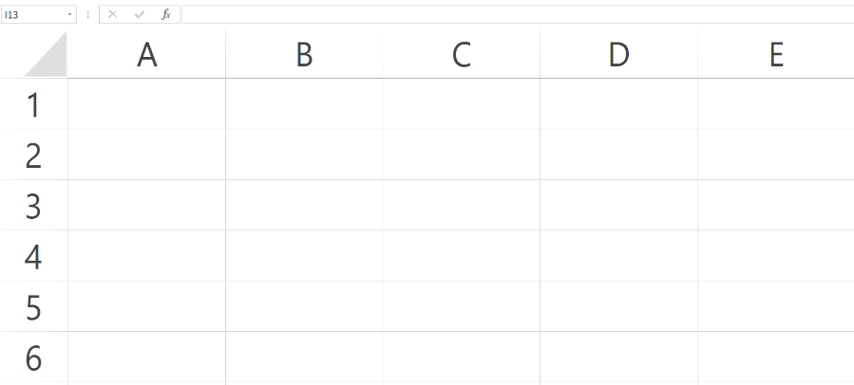

**Ans: _________________**

**c. Match the data with the correct format. /2**

|  |
| --- |
| 24 |
| 14/8/2000 |
| Sana |
| $10.00 |

|  |
| --- |
| Data |
| Currency |
| Number |
| Text |

**VII) David’s Ice cream parlor. /1**

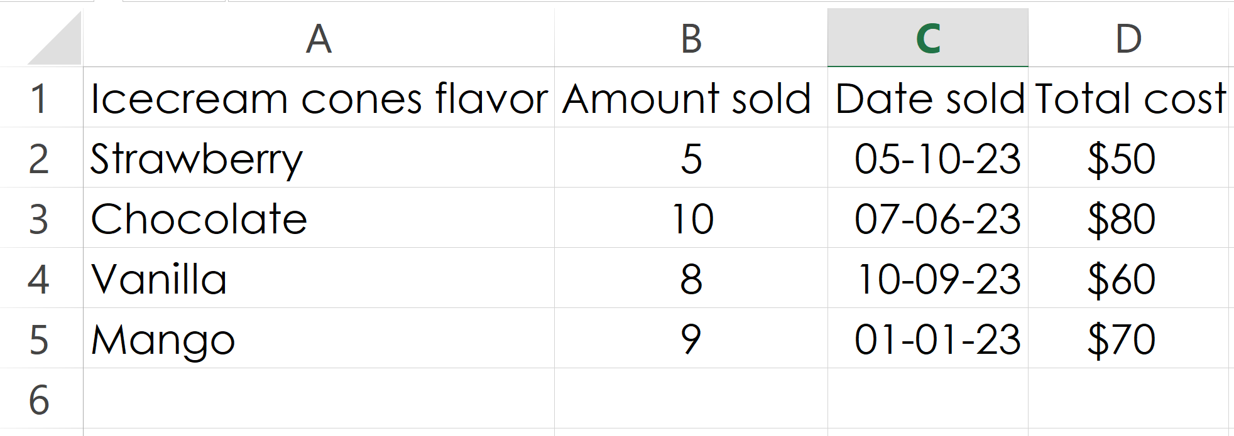

**a. We need to get a list of ice cream cone flavors that were sold at David’s ice cream parlor.**

**What range of cells should be selected?**

A. B2:B5 B. A2:A5 C. C2:C5 D. D2:D5

**b. We need to find out the costs of the ice creams.**

**What range of cells should be selected?**

A. A2:A5 B. C2:C5 C. D2:D5 D. B2:B5

**VIII) a. What is hardware and give 1 example. /1**

**______________________________________________________________________________**

**______________________________________________________________________________**

**______________________________________________________________________________**

**b. State three categories of hardware devices that make up a working computer system. /1.5**

**______________________________________________________________________________**

**______________________________________________________________________________**

**______________________________________________________________________________**

**c. What is software? What is the other name for software? /1.5**

**______________________________________________________________________________**

**______________________________________________________________________________**

**______________________________________________________________________________**