**Revision**

* Session 3: Amazing Invertebrates
* Session 4: Fantastic Fish and astounding amphibians

1. Identify the group of the given six invertebrates using the identification key. They will also include each group’s feature/characteristic in the table.

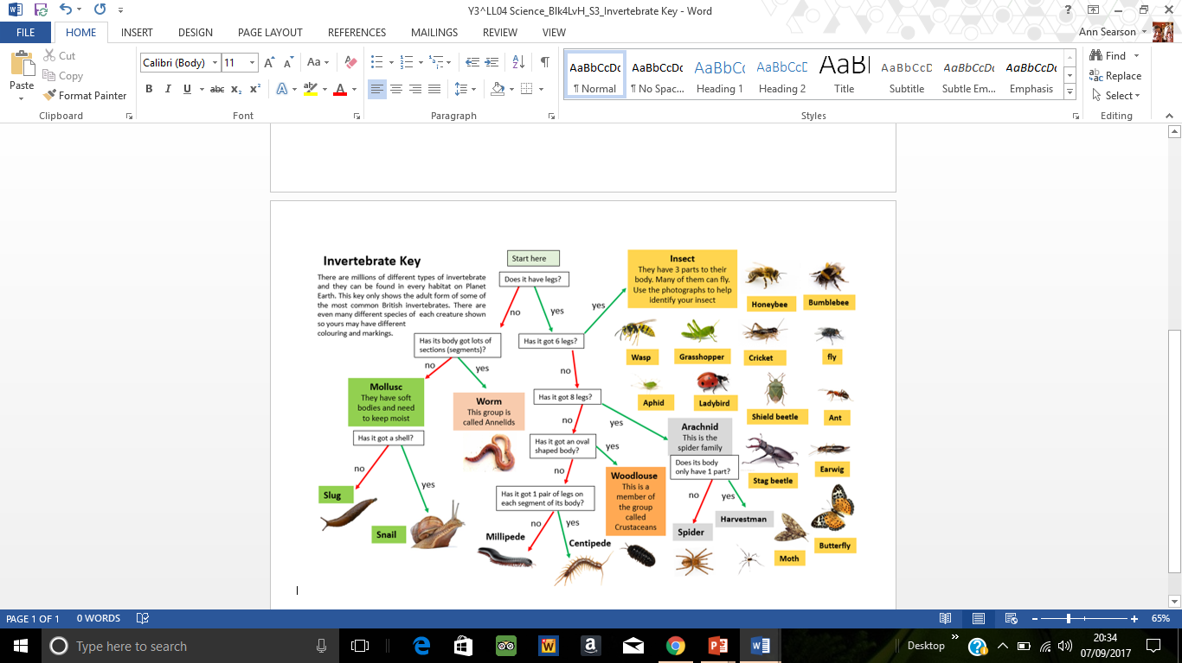

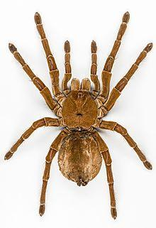 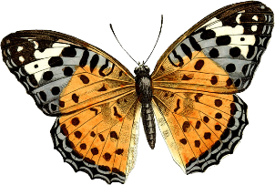 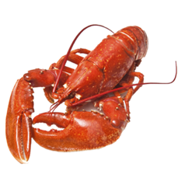 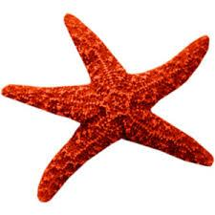 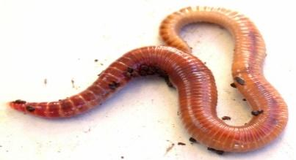

worm

Star fish

lobster

Butterfly

Spider

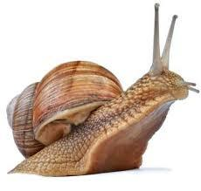 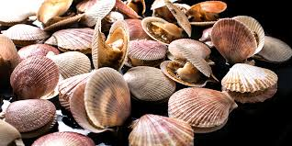 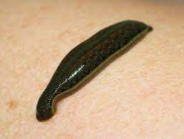 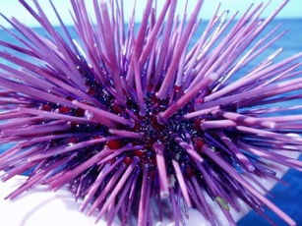

Snail

Sea urchin

Leech

scallops

|  |  |  |
| --- | --- | --- |
| **molluscs** | **annelids** | **echinoderms** |
| **Characteristics:** | **Characteristics:** | **Characteristics:** |
| **crustaceans** | **insects** | **arachnids** |
| **Characteristics:** | **Characteristics:** | **Characteristics:** |