WORKSHEET MS
1a  2 a | 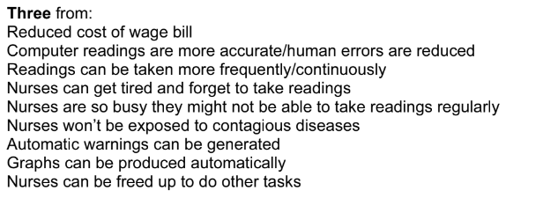  Three from :  Temperature  Blood pressure  Pulse  Respiration rate  Quantity of food intake | 3  3

