Unit 5: Networks are everywhere Worksheet 27
Network devices
Name:
Label the devices below. Use the words in the word bank.
security camera multifunction machine desktop e-reader
laptop scanner games console smartphone printer
tablet smart TV Internet Phone portable game
Device Device name      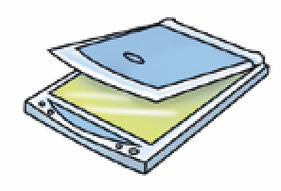  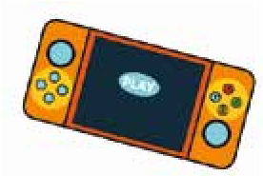       | Device Device name        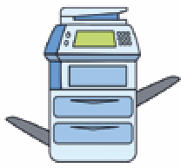  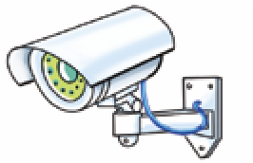  

List other computing devices not shown in the table that you may have seen at school or at home:

_______________________________________________________________________________________________
_______________________________________________________________________________________________
_______________________________________________________________________________________________

Cambridge Primary Computing Stage 3 © Hodder & Stoughton Limited 2023

