**Input and Output devices**

**Question 1:**

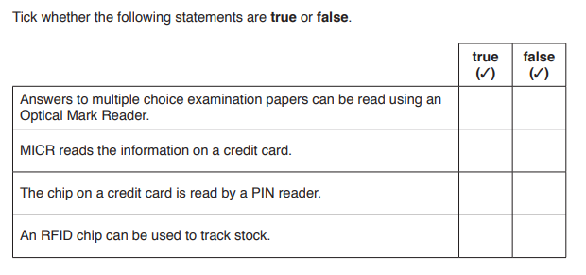 **[4]**

**Question 2:**

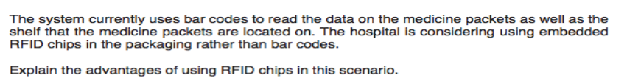

-----------------------------------------------------------------------------------------------------------------------------------------------------

------------------------------------------------------------------------------------------------------------------------------------------------------

------------------------------------------------------------------------------------------------------------------------------------------------------

------------------------------------------------------------------------------------------------------------------------------------------------------

------------------------------------------------------------------------------------------------------------------------------------------------------

------------------------------------------------------------------------------------------------------------------------------------------------------

------------------------------------------------------------------------------------------------------------------------------------------------------

------------------------------------------------------------------------------------------------------------------------------------------------------

------------------------------------------------------------------------------------------------------------------------------------------------------

----------------------------------------------------------------------------------------------------------------------------------------------------[6]