1. $c$ is inversely proportional to $d^{2}$. Given that $c=12.5$ when $d=4$.
   1. Find the formula connecting $c$& $d$.
   2. Use this formula to find $c$ when $d=10$
   3. Use your formula to find $d$ when $c=8$
2. A ball falls d metres in t seconds. d is directly proportional to the square of t. The ball falls 44.1m in 3 seconds.

## Find a formula for d in terms of t

* 1. Calculate the distance the ball falls in 2 seconds.

1. The diagram shows the speed—time graph for the first 120 seconds of a car journey.

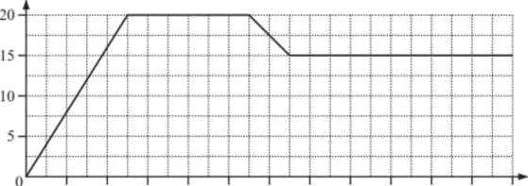

* + - * + Calculate the acceleration of the car during the first 25 seconds.
* Calculate the distance travelled by the car.

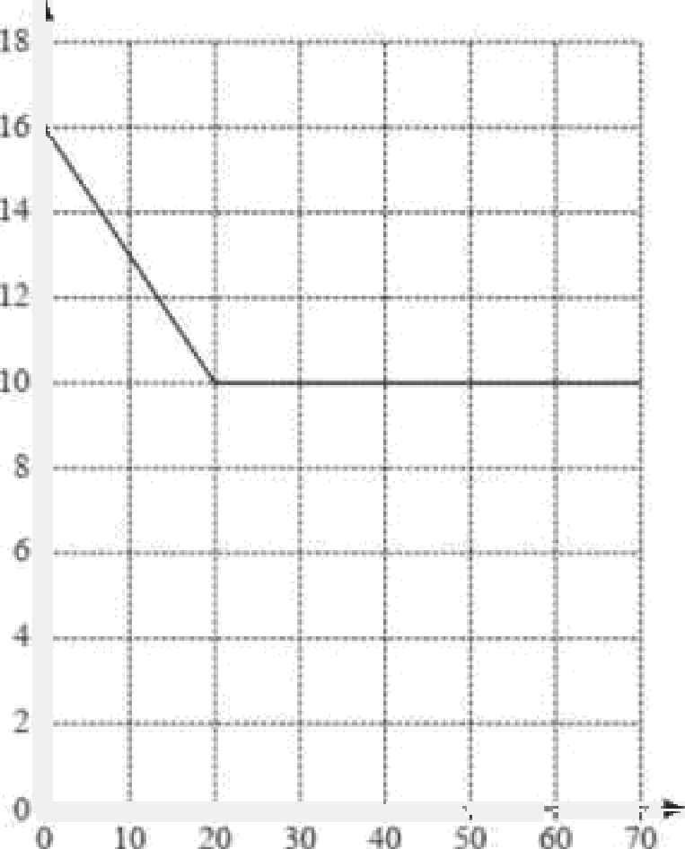

* + 1. Calculate the deceleration of the car during the first 20 seconds.
    2. Calculate the total distance travelled by the car during the 70 seconds.

1. The diagram shows the position of a boat B and a dock D

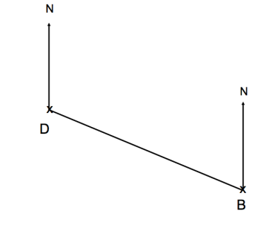

The scale of the diagram is 1cm represents 2km.

(a) Work out the actual distance between the dock and the boat. .........................km

(b) Measure the bearing of the boat B from the dock D. ...............................⁰ (1

A yacht Y is 8km from the boat B on a bearing of 050⁰

On the diagram, mark the position of yacht Y with a cross (x). Label it Y

1. The diagram shows the position of two airplanes, P and Q.

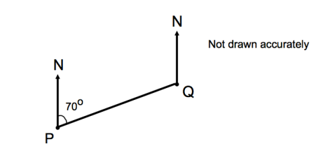

The bearing of Q from P is 070⁰. Calculate the bearing of P from Q.

The diagram shows the position of two people, A and B, who are on their Duke of Edinburgh expedition.

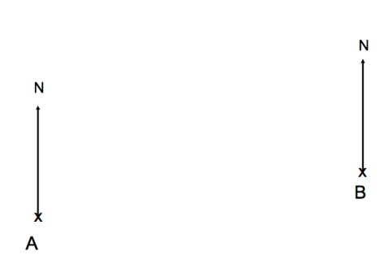

The bearing of person C from person A is 062⁰ . The bearing of person C from person B is 275⁰ In the space above, mark the position of person C with a cross (x). Label it C.

1. A ladder is placed against a wall. To be safe, it must be inclined at between 70⁰ and 80⁰ to the ground.

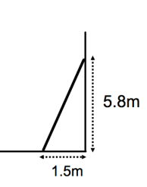

* + - 1. Is the ladder safe? Explain your answer
      2. Calculate the length of the ladder.

1. Shown below is a parallelogram

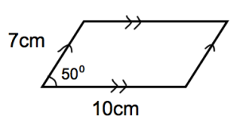

Calculate the area of the parallelogram.

