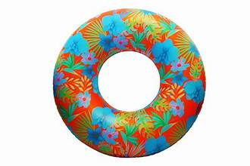 beach float arm floater  
  
  
  
  
  
  
  
  
  
  
  
  
  
  
  
 float saver