Light and Shadow
Unit 3.4 Translucent Material
Use these words to complete the sentences below.
visor translucent opaque blocked scatter shadow frosted goggles
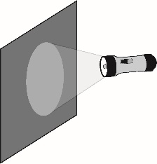  Light cannot get through the _______________ material. | 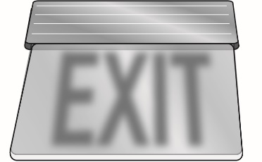  Light is scattered by the  _______________ material.
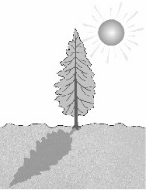  A dark _______________  is made when light is blocked. | 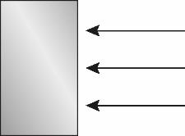  Light cannot pass when it is _______________.
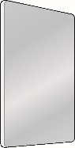  Light is scattered by the _______________ glass. | 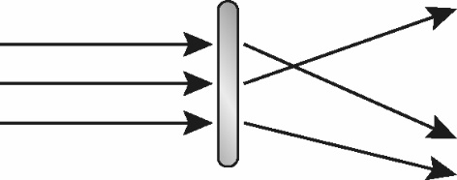  Translucent materials will _______________ light.
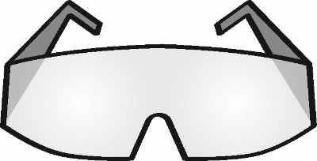  Wear _______________  to protect your eyes. | 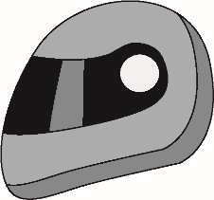  The _______________ on the  helmet will protect your eyes.

Answer the following questions:

- Do translucent objects reflect light?

Translucent and Opaque objects reflect most of the light that falls on them. Whereas, transparent objects lets all the light pass through them.

- Can you think of any practical uses for translucent materials? Why might we use them instead of opaque materials?

The fabric used for the lampshade is a good example. Translucent lampshades allow light to escape through the sides of the shade and spread light evenly across the room.

- Write three differences between transclucent and transparent objects.

Transparent Objects | Translucent Objects
Allows all the light to pass through it. | Allow some light or most of the light to pass through it
Light passes straight through it | Light gets scattered
Do not reflect light | They reflect light

No. | Self-Reflection Criteria | Yes | No
1 | I can talk about transparent, translucent and opaque materials.
2 | I can draw a diagram to show how translucent material scatter light.

