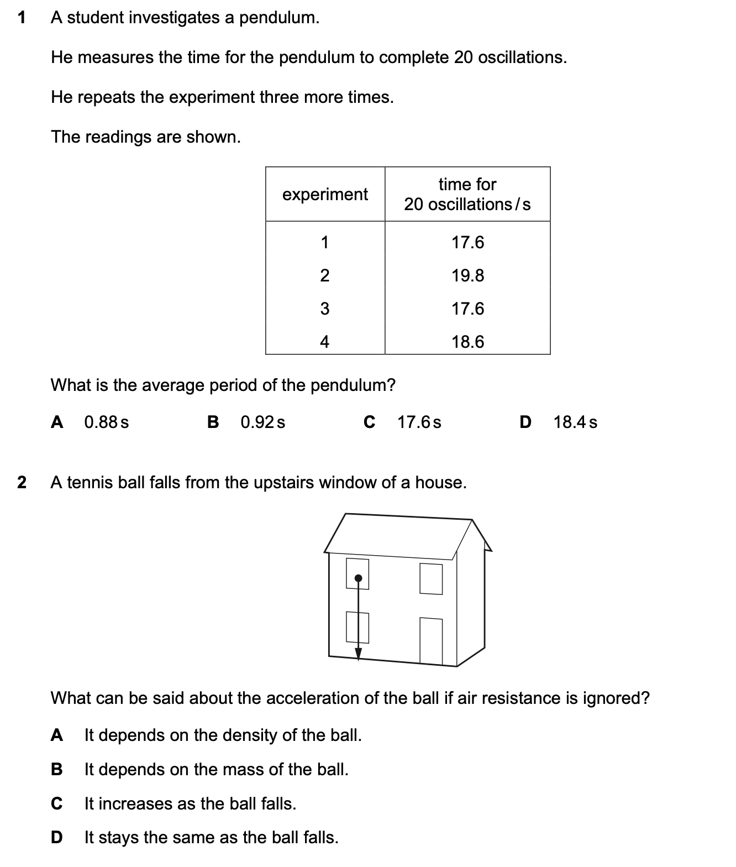**Quiz-1**

