The Trial Balance

Question 1

Type of errors
Rent of premises debited to the premises account

Sales to R Singh debited to H Singh’s account

Balance on cash account over-stated by $10 and balance on sales account over-stated by $10.

Cash sales debited to the sales account and credited to the cash account.

Question 2

At the end of April 2000, an inexperienced bookkeeper prepared the following trial balance for Khalid Hassan.

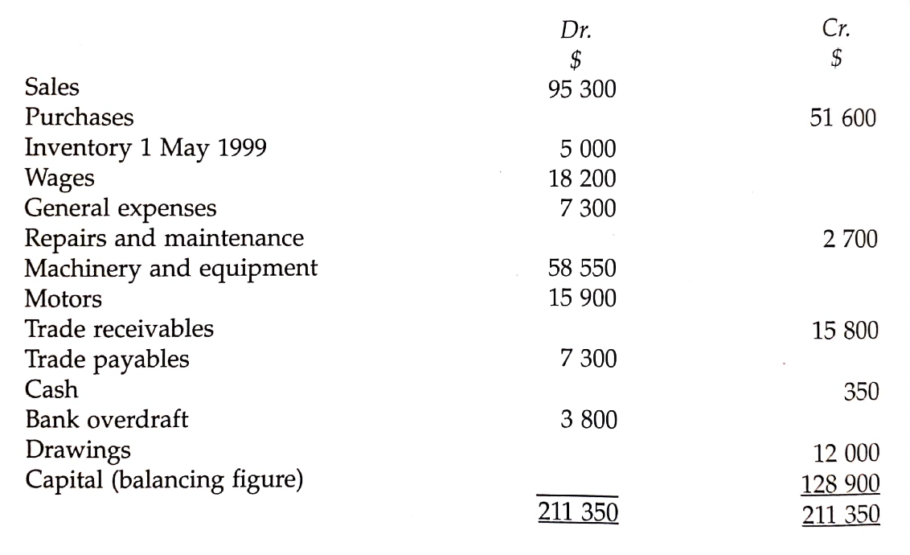

In addition to the obvious errors in the trial balance, the accountant was also able tob discover the following errors, which the trial balance failed to disclose.

- $150 for the cost of repairing a motor had been debited to the motors account.
- $50 cash paid for general expenses had not been recorded.
- Errors of addition had been made resulting in the sales being overcast by $100 and the wages being overcast by the same amount.
- When an invoice for goods purchased on credit was recorded the amount was entered as $1000 instead of $100.
- A cheque received from a debtor for $200 had been debited to the debtor’s account and credited to the bank account.

- Complete the table given below.

Items | Type of errors
1

2

3

4

5

- Prepare an amended trial balance for Khalid Hassan for 30 April 2000 showing the correct capital balance.

……………………………………………………………………………………………………………………………………………….

……………………………………………………………………………………………………………………………………………….

……………………………………………………………………………………………………………………………………………….

……………………………………………………………………………………………………………………………………………….

……………………………………………………………………………………………………………………………………………….

……………………………………………………………………………………………………………………………………………….

……………………………………………………………………………………………………………………………………………….

……………………………………………………………………………………………………………………………………………….

……………………………………………………………………………………………………………………………………………….

……………………………………………………………………………………………………………………………………………….

……………………………………………………………………………………………………………………………………………….

……………………………………………………………………………………………………………………………………………….

……………………………………………………………………………………………………………………………………………….

……………………………………………………………………………………………………………………………………………….

……………………………………………………………………………………………………………………………………………….

……………………………………………………………………………………………………………………………………………….

……………………………………………………………………………………………………………………………………………….

……………………………………………………………………………………………………………………………………………….

……………………………………………………………………………………………………………………………………………….

