QUIZ-5
Chapter1 (Marking Scheme)

Sl.No | Answers | Marks
1 | - GUI is more user-friendly because users can use icons, drop-down lists or graphics to do specific tasks like opening an application software  - It is easier to be used by disabled people because a joystick can be used with GUI  - It uses a lot of memory space because of the icons it uses  - Users are limited to do certain tasks because the command is already predetermined by the creator | 4
2 | - Smartphone  - Desktop  - Smartphone  - Laptop | 4
3 | 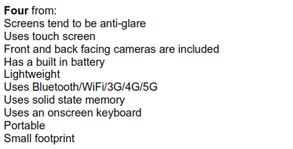 | 2

