1. 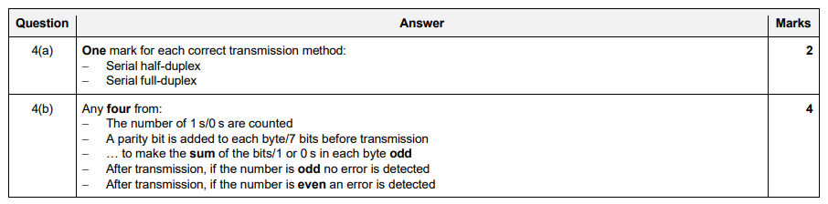

1 a

5 b



5 c

1. Compare Symmetric and Asymmetric Encryption. (At least 3 points for Each)

|  |  |
| --- | --- |
| **Symmetric Encryption** | **Asymmetric Encryption** |
| * Advantages:   + Simple   + Faster * Disadvantages:   + Key must exchanges in secure way   + Easy for hacker to get a key as it is passed in unsecure way. | * Asymmetric Key Cryptography (Public Key Cryptography)   + 2 different keys are used   + Users get the Key from an Certificate Authority   Advantages   * 1. More Secured   2. Authentication   Disadvantages   * 1. Relatively Complex |

[3]