**Types and components of a computer system**

1. Complete the following sentences, using the most appropriate items from the list below.

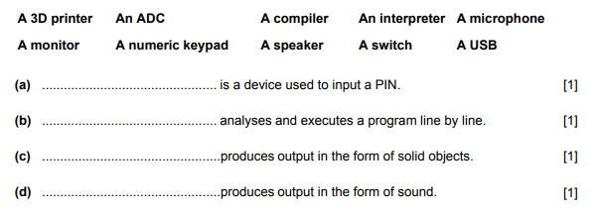

1. Circle the names of three devices which are used for input.

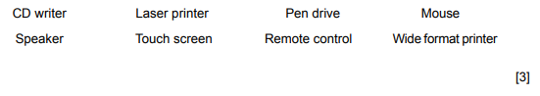

1. Complete each sentence using words from the following list.

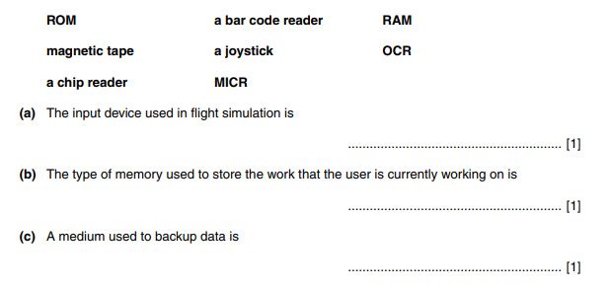

1. Draw five lines on the diagram to match the input device to its most appropriate use.

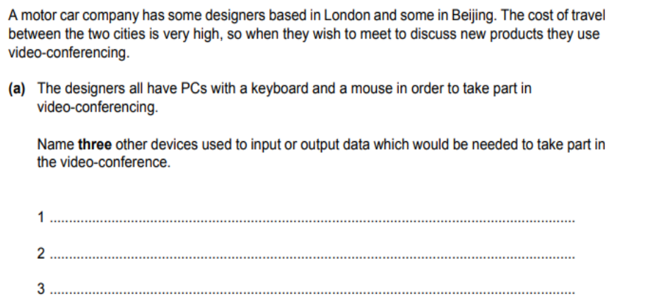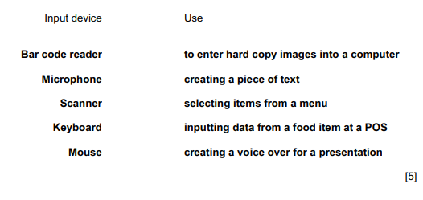

5.

[3]