**Types and components of a computer system**

**Question 1:**

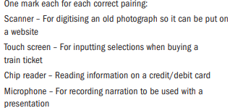

Question 2:

One mark for each one of the following:

Pressure sensor,Touch Screen,Mouse,RFID reader,MICR,Barcode Reader

Question 3:

